Joseph Edgar Cambre Jr.
May 6, 1949 – March 16, 2024

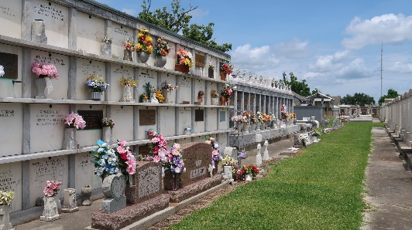

Joseph Edgar Cambre, Jr. departed this life on Saturday, March 16, 2024, at the age of 74. Husband of Andrea S. Cambre for over 19 years, he is the father of Ryan (Tiffany) Cambre, Tai Cambre and Jamaal Cambre, Sr. and raised his brother-in-law Christopher (Dion) Stewart as his own. Adoring grandfather of Jamaal, Jr., Chloe’, Lian, Lila, Ethan and Vannah Cambre.
He graduated from St. Augustine High School in 1967 and was a proud Purple Knight. He attended Dillard University before enlisting in the United States Navy where he earned a National Defense Service Medal and a Vietnam Service Medal. “Edgar Jr.” was a proud Navy Veteran and was employed by E. I. DuPont for over 35 years.
He is preceded in death by his parents Edgar and Helen Cureaux Cambre, grandparents Christopher and Fedora W. Cambre, Andouche and Rose C. Cureaux, his brother Aaron Cambre and sister Joyce Cambre, three brothers-in-law Ronald Rivers, Sr., Royal Gray, Jr. and Louis Gardner, Sr. and nephews Ronald Rivers, Jr. and Robbie Rivers. Devoted brother of Barbara Rivers, Terry Gardner, Paula Joseph, Paulette Montgomery, Claudette (Everette, Sr.) Taylor, Fedora (Andrew, Sr.) Johnson, Barry (Veronica) Cambre, Andouche Cambre, Randy (Audrey) Cambre, and Hollis, Sr. (Schandra) Cambre. Nephew of Roy (Mable) Cureaux and Anna Mae Fredericks. Also survived by a host of nieces, nephews, relatives, and friends.
Relatives and friends of the family, also priests and parishioners of Our Lady of Grace Catholic Church and all neighboring churches and employees of E. I. DuPont are invited to attend the Funeral Mass at Our Lady of Grace Catholic Church, 772 Hwy 44 (River Road), Reserve, LA on Monday, March 25, 2024 at 10:00 am. Visitation at 8:15am. Rosary at 9:15am. In lieu of flowers, please donate to the American Cancer Society in remembrance of Joseph Edgar Cambre, Jr. Interment St. Peter Cemetery, Reserve, LA.
D. W. Rhodes Funeral Home, New Orleans, Louisiana

