Karen (Galatas) Cambre
January 1, 1948 – March 27, 2017

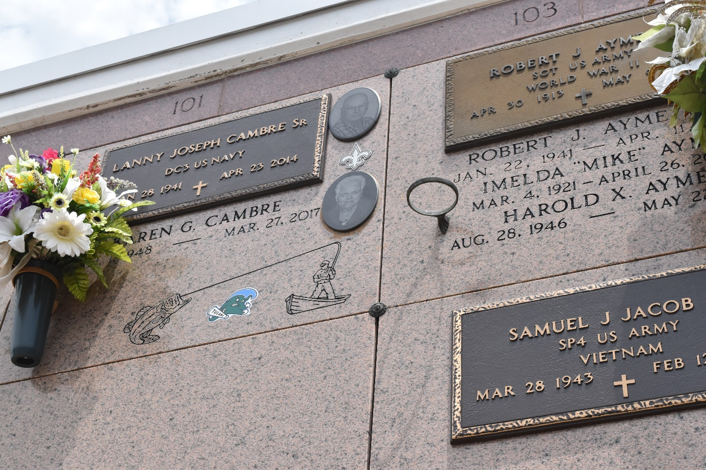

Karen Galatas Cambre passed away on Monday, March 27, 2017 at the age of 69. She was a native and lifelong resident of Garyville.
Beloved wife of the late Lanny J. Cambre Sr. Loving mother of Lanny "L.J." Cambre Jr., Chad M. Cambre (Kristen), Toby J. Cambre (Kristy) and Jason P. Cambre (Richell). Grandmother of Jayci, Erica, Laura and Colston Cambre and Trey Adams.
Daughter of the late Theodore J. Galatas Jr. and Rosa Marie Duhe Galatas. Sister of Barry Galatas (the late Kathy) and Catherine Galatas Templet (Gerald). Also survived by nieces, nephews and godchildren.
Relatives and friends are invited to attend the visitation at Millet-Guidry Funeral Home, 2806 W. Airline Hwy, LaPlace on Friday, March 31, 2017 from 6:00 p.m. to 9:00 p.m. and on Saturday, April 1, 2017 at St. Hubert Catholic Church, 176 Anthony Monica St., Garyville from 9:00 a.m. to 11:00 a.m. The Funeral Mass will immediately follow at 11:00 a.m. Interment in St. Peter Cemetery. To view or sign the online guest book please visit
www.milletguidry.com.

The New Orleans Advocate, Louisiana
March 28- April 1, 2017

