Lanny Joseph Cambre Sr.
January 29, 1941 - April 23, 2014

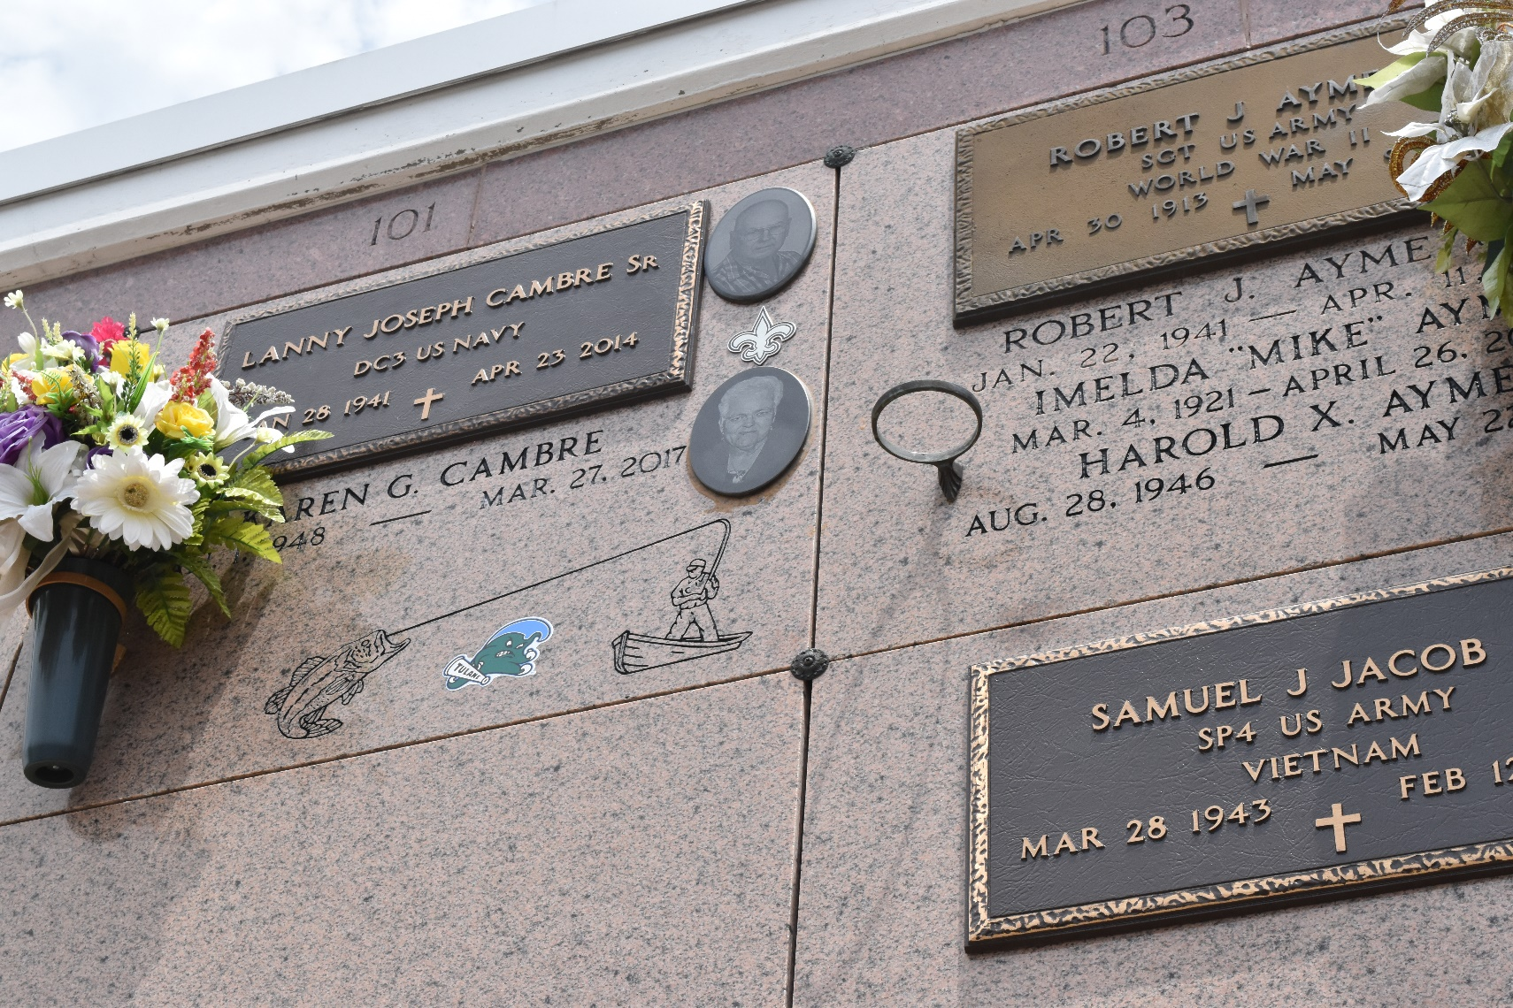

Lanny J. Cambre Sr., died on Wednesday April 23, 2014.

Beloved husband of Karen Galatas Cambre. Father of Lanny (L.J.) Cambre Jr., Chad M. Cambre (Kristen), Toby J. Cambre (Kristy) and Jason P. Cambre (Richell). Grandfather of Jayci, Erica, Laura, Colston Cambre and Trey Adams.

Son of the late Frank and Elsie Badeaux Cambre. Brother of Norma Fremin, T-Boy Cambre, Nelwyn Jacob, Eddie Cambre Sr., and the late Kathleen Cambre. Age 73. A native and resident of Garyville, LA.

TheNewOrleansAdvocate.com
Apr. 25 to Apr. 26, 2014

