Lewis Wilfred Cambre Jr.

September 27, 1927 – January 14, 2004

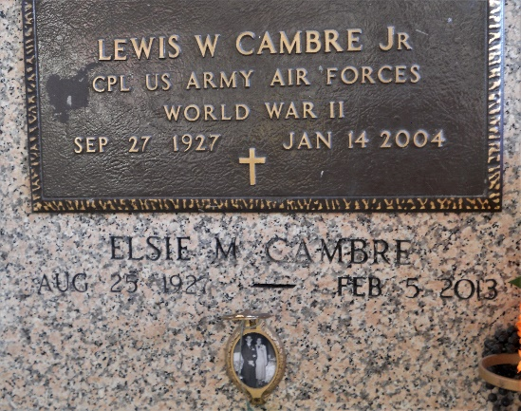

Lewis Wilfred Cambre, Jr, passed away at his home on Wednesday 14 Jan 2004 at age 76 years.

Beloved husband of Elsie Matherne Cambre for 54 years. Father and father-in-law of Kathleen Cambre of Reserve, Louisiana, Marie and Charles Ursa of Branson, Missouri, Lewis III and Carla Cambre of Lutcher, Louisiana, Lyle and Drema Cambre of Grand Point, Louisiana, and Elsie Cambre of Garyville, Louisiana.

He was the son of the late Marie Virginia and Lewis W Cambre, Sr. Survived by brothers and sisters: A Bert Cambre of Lutcher, Rita Morvant of Kenner, Louisiana, Aline Duhe of New Orleans and Russell Cambre of Reserve. Bother of the late Marie Louise Roussell, Ruth Brignac, Josie Snowdy, Ellis and Caliste Cambre. Also survived by 12 grandchildren and 12 great grandchildren.

He was born in Reserve and was a resident of Garyville for 40 years. He was a member of the Sheetmetal Union Local 11, New Orleans, and a lifetime member of V.F.W. Post 8167 of Garyville.

Funeral services were at St Hubert's Catholic Church, Garyville, on Saturday, 17 Jan 2004 with interment immediately following at St. Peter's Cemetery in Reserve.

The Times-Picayune, New Orleans, Louisiana

January 16, 2004