Lewis Wilfred Cambre Sr.
October 30, 1882 – February 25, 1974

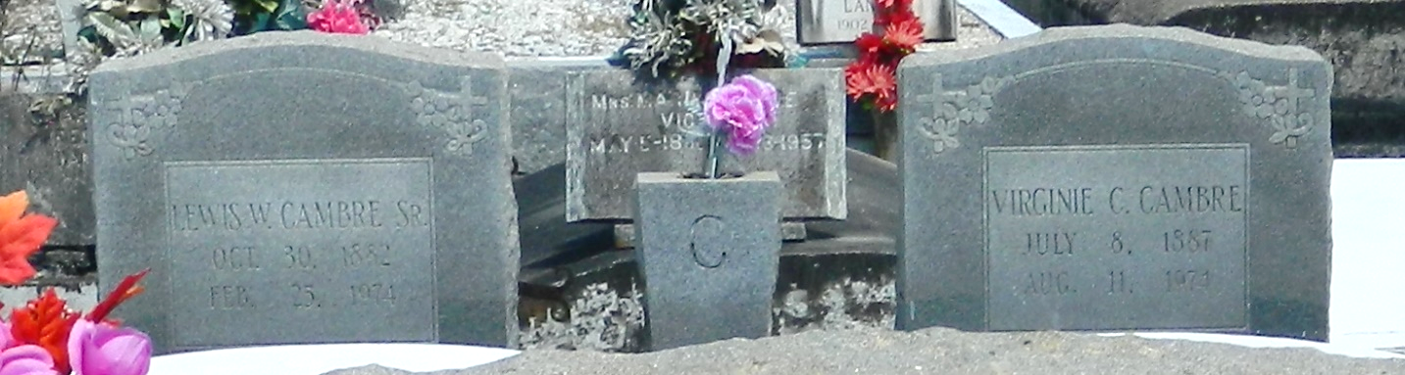

Age 91 years, a native and resident of Reserve, Louisiana.

Husband of Virginia Cambre, father of Mrs. L. J. (Louise) Roussell Sr, Caliste Cambre, Mrs. Wilbur (Rita) Morvant, Mrs. Raymond (Ruth) Brignac Sr, Mrs. Oliver (Aline) Duhe Jr, all of New Orleans, Ellis Cambre of Gretna, Louisiana, Bert Cambre of Mobile, Alabama, Lewis Cambre Jr of Garyville, Louisiana, Mrs Jack (Josie) Snowdy of Reserve and Rusell Cambre, U.S. Army.

Services were Tuesday 26 Feb 1974 at St Peter Church, Reserve, with interment in St Peter Cemetery.

The Times-Picayune, New Orleans, Louisiana
Unknown date

