Lionel Joseph Cambre Jr.

May 25, 1934 – August 27, 2002

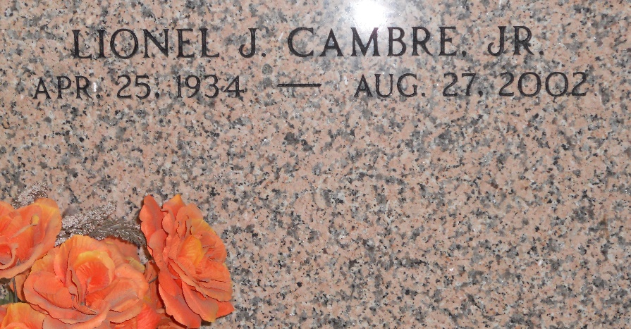

Photo by Team T-Lo

Lionel 'Peck' Cambre Jr. On Tuesday 08-27-2002 At 8:21 P.M.

Beloved Husband Of Clara Kennedy Cambre. Father Of Thomas J. Cambre Sr. Grandfather Of Thomas Jr And Zachary Cambre. Son Of Alice Cambre And The Late Lionel Cambre Sr. Brother Of Ronald Cambre. Age 68. A Native Of St. Rose And A Resident Of Laplace For The Past 28 Years.

Relatives And Friends Of The Family Also Employees Of Shell Oil Refinery Are Invited To Attend Services. Visitation At Millet-Guidry Funeral Home, 2806 West Airline Hwy, Laplace On Friday August 30, 2002 From 5 P.M. Until 9 P.M. And On Saturday August 31, 2002 From 9am Until 10 Am At Ascension Of Our Lord Catholic Church, 1900 Greenwood, Laplace. Followed By Religious Services At 10 A.M. Burial In St. Peter Cemetery, Reserve

The Times-Picayune, New Orleans, Louisiana

August 29, 2002