Lorraine (Duhe) Cambre

October 21, 1923 – October 30, 2014

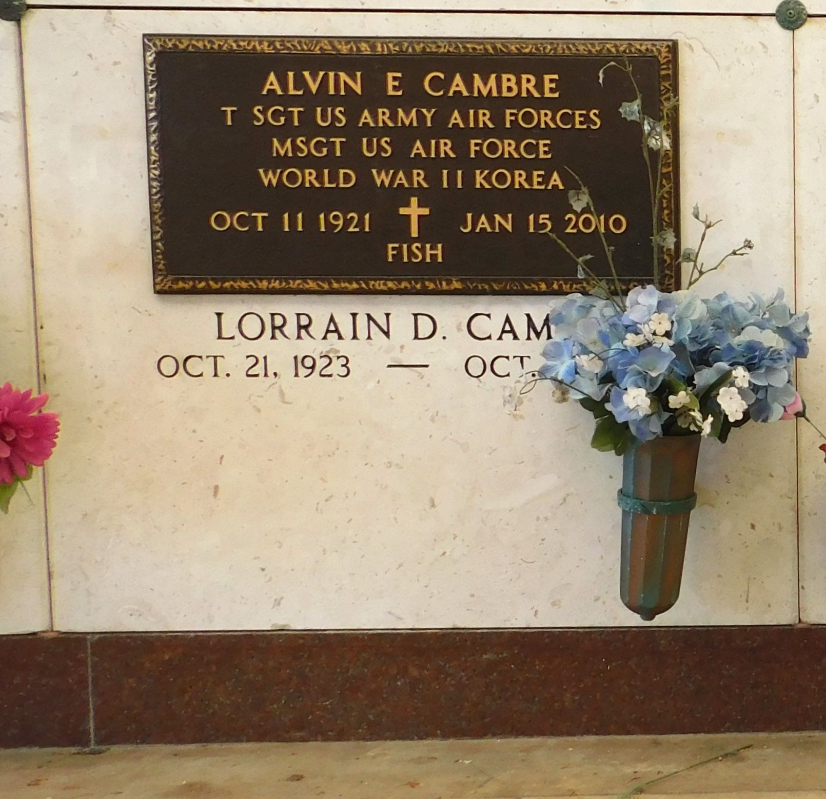

Photo by Mary Agnes Hammett

Lorraine D. Cambre, passed away October 30, 2014 at the age of 91 years old.

Daughter of the late Hypolite and Martha Duhe. Wife of the late Alvin “Fish" Cambre. Mother of Gregory Cambre. Devoted friend of Donna Griffith. She was loved by many. Also survived by a nephew, a host of cousins, other relatives and friends.

Graveside service will be held at St. Peters Cemetery, 1550 Highway 44, Reserve, La. on Saturday, November 8, 2014 for 10:00 a.m. Funeral entrusted to The Baloney Funeral Home, LLC., 1905 W. Airline Highway, LaPlace, La., 985-224-8460.

The New Orleans Advocate, Louisiana

Nov. 6 to Nov. 8, 2014