Louis Amilcar Cambre
July 17, 1891 – October 4, 1971

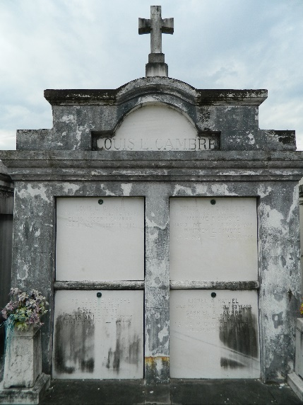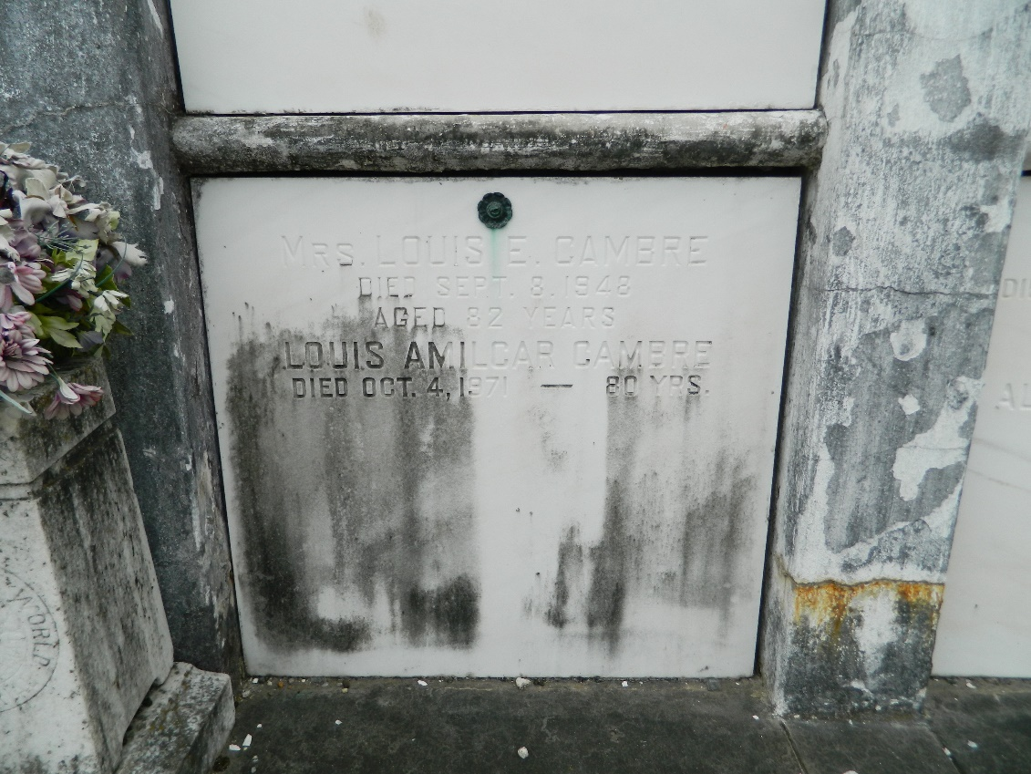

Louis Amilcar Cambre, a native and resident of Laplace, Louisiana, died Monday 4 Oct 1971 at 11:25 p.m. at age 80 years.

He was the son of the late Louis Cambre and Ada Perilloux and the brother of Gabriel Cambre and Mrs. Alma Haydel both of New Orleans, Walter, Whitney and Maxime Cambre all of Laplace, and Ellis Cambre of Jefferson Parish, Louisiana. Also survived by one niece and two nephews.

Services were Tuesday 5 Oct 1971 at St Joan of Arc Church, Laplace, with interment in St Peter Cemetery, Reserve, Louisiana.
The Times-Picayune, New Orleans, Louisiana
6 Oct 1971

