Louis Eusebe Cambre
February 13, 1869 – February 3, 1941

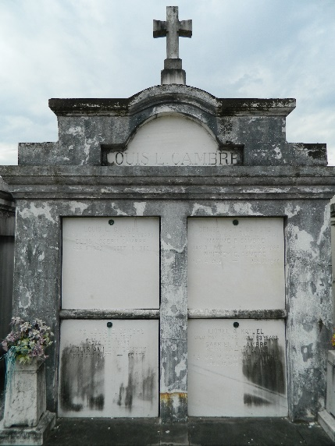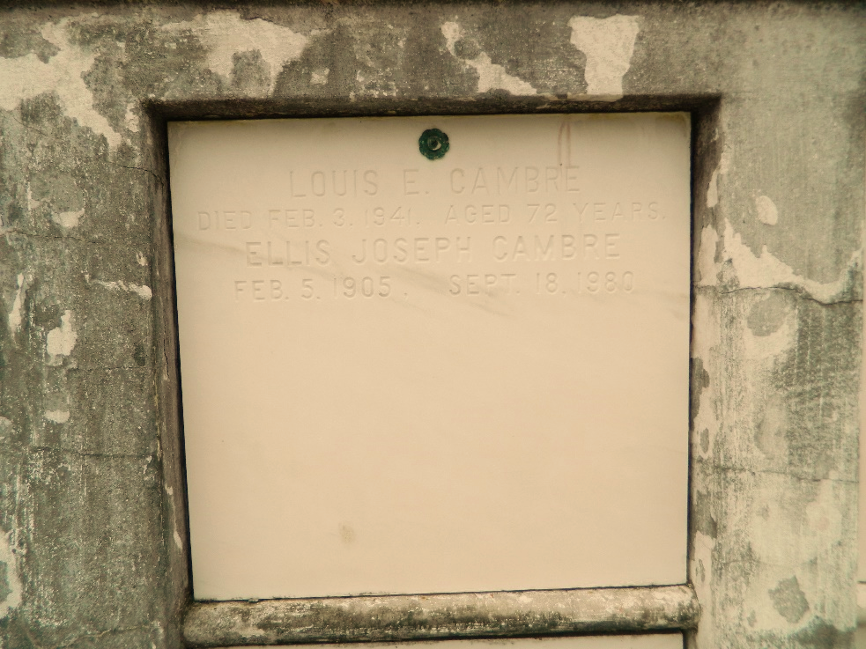

Louis Eusebe Cambre died at Laplace, Louisiana, on Monday 3 Feb 1941 at 11:45 a.m. at age 71 years, 11 months and 9 days.

He was the husband of Ada Perilloux and the father of Mrs. Lionel Haydel and Louis A, Denise, Gabriel, Walter, Whitney, Ellis and Maxine Cambre.

Services were Tuesday 4 Feb 1941 at St. Peter Church, Reserve, Louisiana, with interment in St. Peter Cemetery, Reserve.
The Times-Picayune, New Orleans, Louisiana
February 4, 1941

