Lucien Cambre Jr.

September 8, 1920 - December 5, 2019

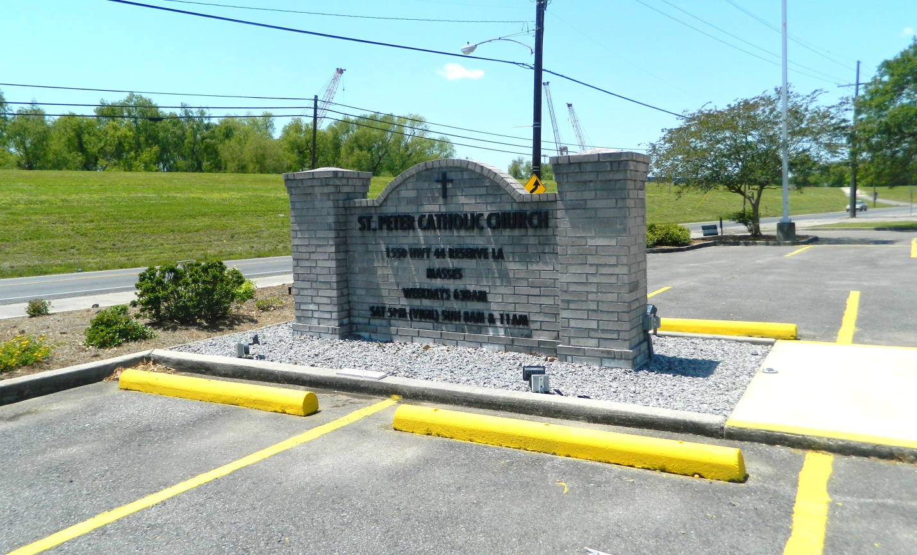

Lucien Cambre, Jr. entered peacefully into eternal rest on Thursday, December 5, 2019 at the age of 99.

Beloved husband of Audrey Duhon Cambre married 75 years. Beloved father of Robert (Paulette), Lucien III (Julie), Michael, Kenneth, Mary “Liz” (Rick), Pamela (Blaine) Louque, Richard (Kim). Preceded in death by his son, Don, Parents Lucien Sr. and Genevieve Bourgeois, siblings, Joseph (Katherine), Edward “Pooney” (Shirley), Parker (Florence), Maurice (Maizie) and Pearl (Lloyd) Gautreaux, grandchildren Robert “Robbie”, Angela “Angie”, and great grandchild, Michael “Moo” Green. Grandfather of 16, Great Grandfather of 21 and Great, Great Grandfather of 6.

He served in the U.S. Air Force for 3 years. Retired from Godchaux after 39 years of service. Scout Master of Troop 316. Served as Auditor of Reserve Credit Union for 25 years. Past President of St. John Theater and active member for 25 years. Member of the Lions Club.

He loved Christmas and displaying his Christmas Dickens Village Collection for 15 years. Many neighbors and friends came to view it. He loved to travel and helped everyone in the community and at home. The Cambre family would like to thank the staff of Southeast Louisiana Veterans Home and Hospice In His Care for the care given to him for the past six months. He will be deeply missed.

Family and friends are invited to attend a Celebration of Life at St. Peter Catholic Church, 1550 Hwy 44, Reserve on Tuesday, December 10, 2019 at 11:00 a.m. Visitation at the church from 9:00 a.m. to 11:00 a.m. Interment in St. Peter Cemetery.

Millet-Guidry Funeral Home, LaPlace, LA; December 8, 2019