Marie Aimee (Bacas) Cambre

October 4, 1816 – December 6, 1905

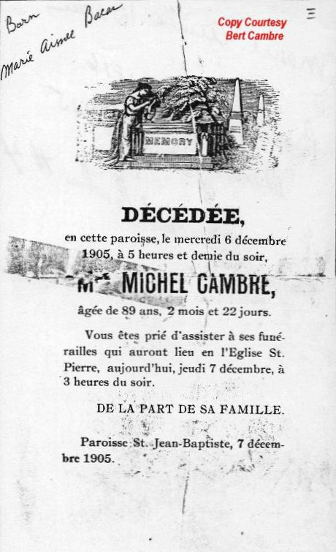

Photo shared by Dwayne Montz