Martin Cambre

March 14, 1900 – August 28, 1957

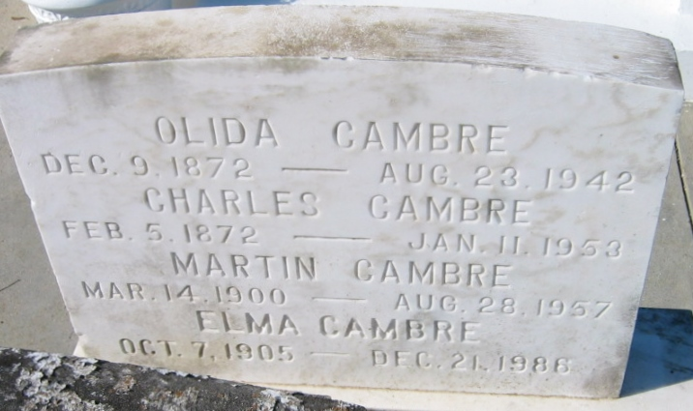

Photo by Bobby

Martin Cambre, age 57 years, died at his home in Laplace, Louisiana, at 2:00 in the morning on Wednesday, 28 Aug 1957.

He was the husband of Elma Gauthreaux and the father of Mrs. Percy Tassin.

Services were Thursday, 29 Aug 1957, at St Joan of Arc Church in Laplace with interment in St Peter Cemetery in Reserve, Louisiana.

Unknown source