Maurice Price Cambre
February 18, 1930 – July 3, 2018

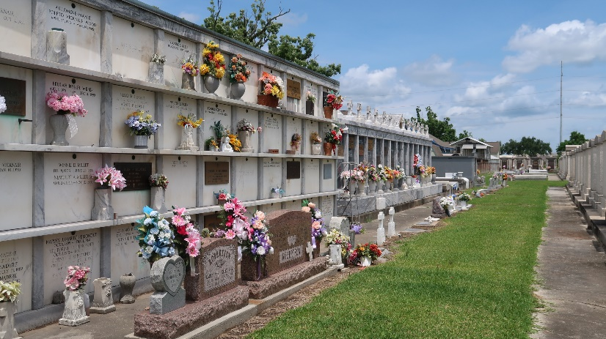

Maurice (Mo) Cambre went to be with the Lord on Tuesday, July 3, 2018. He was born on Feb 15, 1930, to Lucien and Genevieve Cambre. He was married to Eve Maizie Cambre and they had three sons, Terry, Curtis and Jeffrey.
He worked as a mechanic at Monsanto. He enjoyed bowling, duck hunting, coaching baseball and volunteering with the Boy Scouts. He loved the LSU Tigers. After retirement, he ran a comic book shop in LaPlace. His smile was contagious, and his blue eyes twinkled. He was always singing to himself. Later in life, when a stroke left him wheelchair bound, he would travel across Airline Highway and go to PJ's for a coffee and danish. He would go to Walmart where he was known as the "Scooter Man." He enjoyed playing slots at the off-track betting place.
He leaves behind his 3 sons, 5 grandchildren, 7 great-grandchildren and numerous family and friends. He is preceded in death by a grandson. He will truly be missed by all who knew him.
Visitation will be on Monday, July 9, 2018, from 6-9 p.m. at Millet Guidry Funeral Home, 2806 W. Airline Hwy, LaPlace and on Tuesday, July 10, 2018, from 9-11 at St. Joan of Arc Church, 529 W. 5th St., LaPlace with a mass at 11 a.m. Interment in St. Peter Cemetery. Arrangements by Millet-Guidry Funeral Home.

The New Orleans Advocate, Louisiana
Jul. 7 to Jul. 10, 2018

