Olide Thomassin Cambre
August 12, 1872 – November 11, 1923

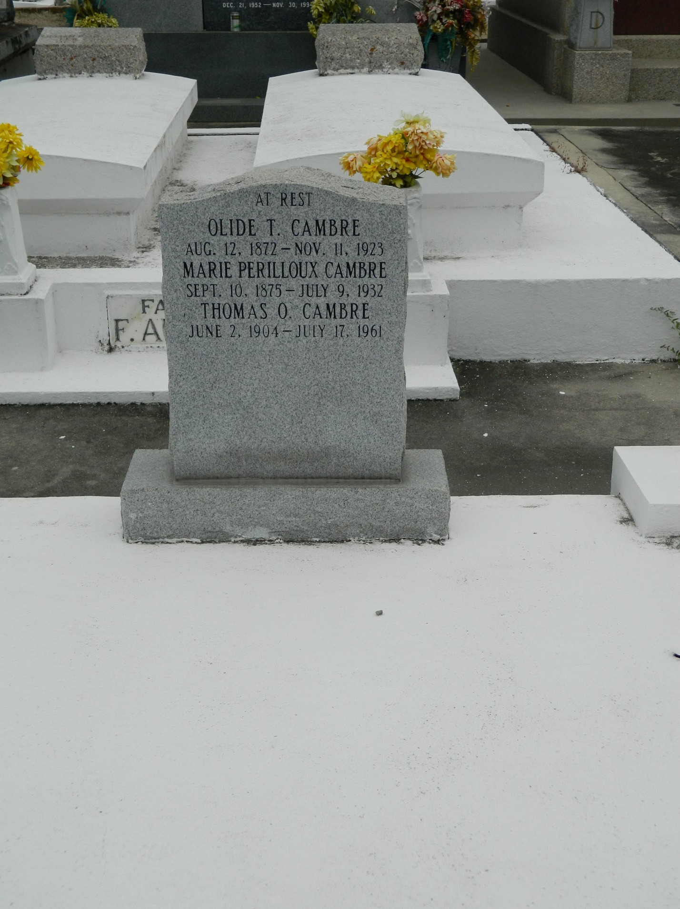

Olide Cambre, husband of Marie Perilloux, died Sunday 11 Nov 1923 at 11:25 am at age 51 years. He was a native of St John the Baptist Parish, Louisiana, and a resident of Destrehan, Louisiana.

Services were Monday 12 Nov 1923 with interment in St Peter Cemetery, Reserve, Louisiana.
The Times-Picayune, New Orleans, Louisiana
12 Nov 1923

