Prudent Bernard Cambre

June 11, 1909 – May 5, 2002

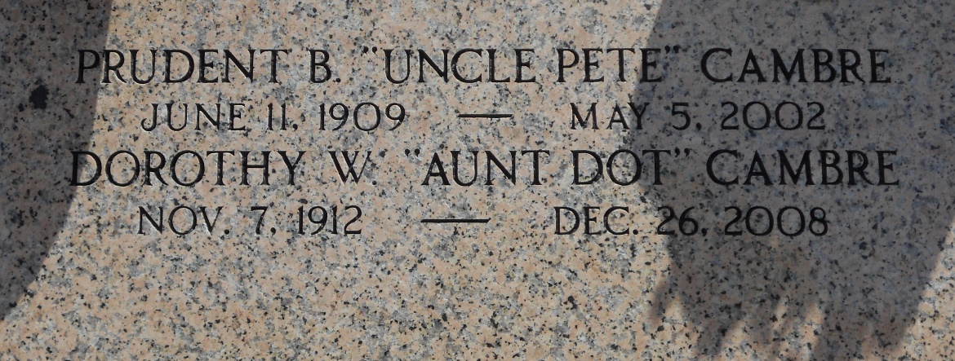

Photo by Team T-Lo

Prudent B. Cambre, a native of Laplace, Louisiana, and a resident of Bryan, Texas, for the past 7 years died in Bryan, Texas, on Saturday, 4 May 2002 at 2:00 p.m. at age 92 years.

He was the husband of Dorothy Wilson Cambre of 66 years. He was the son of the late Raoul and Eva Dufresne Cambre and brother of the late Ruth, Etienne, Guy, Abdon, Edward and Alvin Cambre. Also survived by 4 nieces, and 3 nephews.

Services were Wednesday 8 May 2002 at the chapel of Millet-Guidry Funeral Home, 2806 West Airline Hwy, Laplace, Louisiana, with interment in St Peter Catholic Church Cemetery, Reserve, Louisiana.

The Times-Picayune, New Orleans, Louisiana

May 7, 2002