Regina Cambre
March 25, 1867 – December 30, 1944

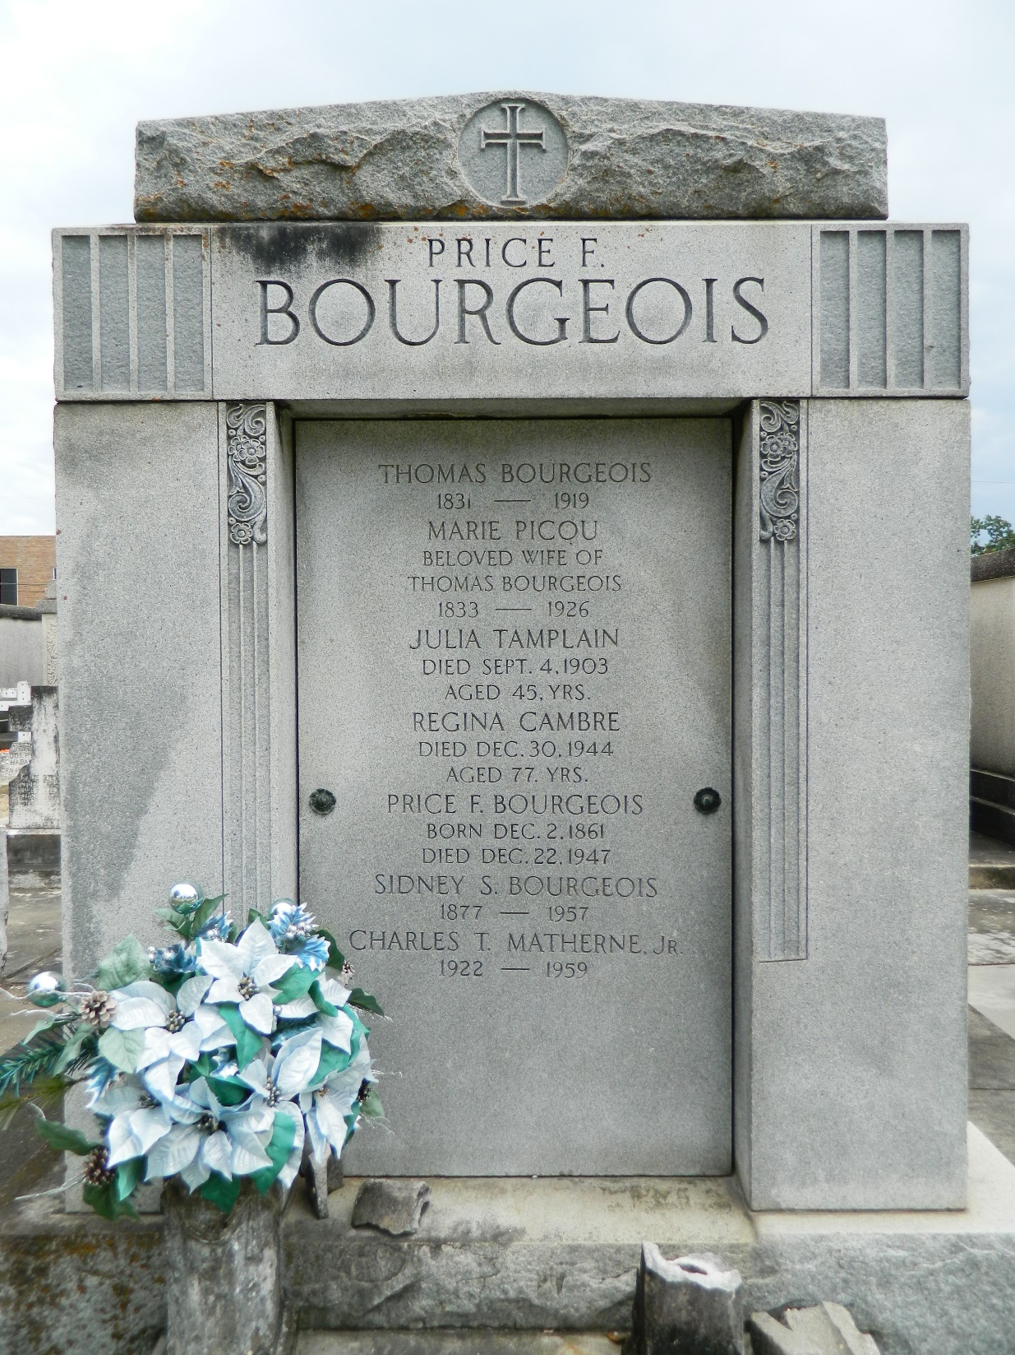

CAMBRE-In Garyville, La, on Saturday, December 30, 1944, at 8:35 o'clock a.m., REGINA CAMBRE, adopted daughter of the late Mr. and Mrs. Thomas Bourgeois of Mt Airy, La, aged 77 years. Relatives and friends of the family are respectfully invited to attend the funeral, which will take place at the residence of Charles Matherne, Garyville, La, on Sunday, December 31, 1944, at 4 o'clock p.m. Religious services at St Hubert church, Garyville, La. Interment in St Peter's cemetery, Reserve, La.
The Times-Picayune, New Orleans, Louisiana
December 31, 1944
Page 2

