Robert L. Cambre Jr.
Abt. 1967 - July 2, 2018
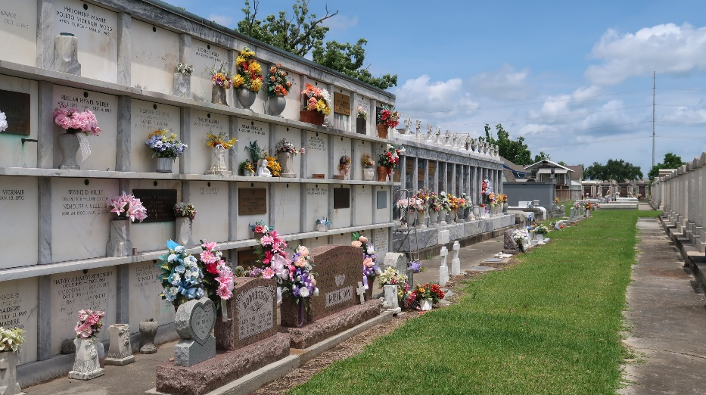

Robert “Robbie” L. Cambre, Jr. passed away at his residence on Monday, July 2, 2018 at the age of 51. He was born in New Orleans and was a resident of LaPlace.

Beloved father of Dakota Cambre. Loving son of Robert L. Cambre, Sr. and Paulette LeBlanc Cambre. Brother of Robin Reid Cambre. Grandson of Lucien and Audrey Cambre and the late Julia Beeland and L.J. LeBlanc. Also survived by many aunts, uncles, nieces, nephews and cousins.
Relatives and friends are invited to attend the Funeral Service at Millet-Guidry Funeral Home, 2806 W. Airline Hwy., LaPlace on Saturday, July 7, 2018 at 11:00 a.m. Visitation from 9:00 a.m. to 11:00 a.m. Interment in St. Peter Cemetery.

Millet-Guidry Funeral Home, LaPlace, Louisiana
July 4, 2018

