Robert L. Cambre Sr.
December 11, 1945 – June 21, 2024

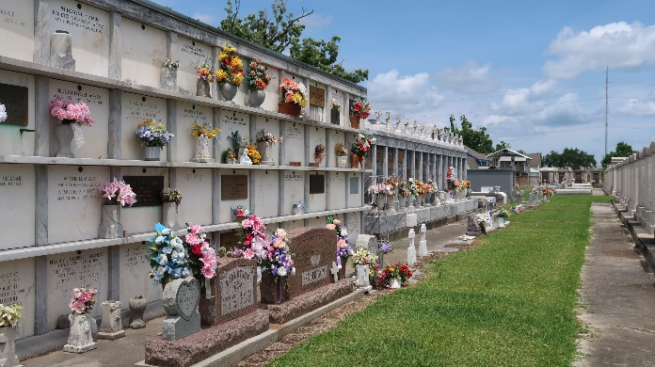

Robert Cambre, Sr. passed away on Friday, June 21, 2024 at the age of 78.
Beloved husband of Paulette Leblanc Cambre 58 years. Loving father of Robin Cambre and the late Robert Cambre, Jr. Grandfather of Angel Cambre, Todd Skelton (Jennifer), Joey Troxclair, Steven Reid, and Daniel Reid. Great-Grandfather of Logan Hirsch, Austin Hirsch, Nicholas Simon, Trenton Simon, Lillyan Burns, Jay Burns, Sebastian Skelton, and Zoey Reid. Great-great grandfather of Dallas Hirsch and Oliver Hirsch.

Son of the late Lucian Cambre II and Audrey Duhon Cambre. Brother of Lucian Cambre III (Julie), Michael Cambre, Kenneth Cambre, Liz Simmons (Rick), Pam Louque (Blaine), Richard Cambre, and the late Don Cambre. Also survived by numerous nieces, nephews, and cousins.
Relatives and friends are invited to attend the Visitation and Funeral Service at Millet Guidry Funeral Home at 2806 West Airline Highway Laplace, LA on Friday, June 28, 2024. Visitation will be held from 12:00 p.m. - 2:00 p.m. With a funeral service to follow at 2:00 p.m. He will then be laid to rest in St. Peter’s Cemetery, Reserve, LA.

Millet-Guidry Funeral Home, LaPlace, Louisiana

