Theodule Cambre
February 6, 1883 – November 20, 1966

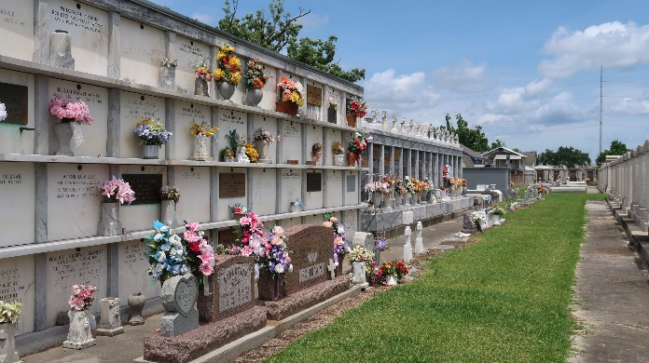

He married Apr 1907, ,1 Marie Clarisse BERTHELOT, b. 16 Nov 1888 in St.John the Baptist Pr., LA,2 bpt. St.John the Baptist Catholic Church-Edgard,LA (SJB 12/36),2 d. 28 Dec 1933.
Parents
Charles Amedee CAMBRE, b. 2 Aug 1842 in St.John the Baptist Pr., LA, bpt. St.John the Baptist Catholic Church-Edgard,LA (SJB 6/88), bur. St.Peter's Catholic Church-Reserve,LA. , He married 187? in St.John the Baptist Catholic Church-Edgard,LA (SJB 4/350), Coralie Septima MADERE.
3. Coralie Septima MADERE, b. 18 Nov 1853 in St.John the Baptist Pr., LA,7, bpt. St.John the Baptist Catholic Church-Edgard,LA (SJB 6/340),7 d. 14 Nov 1942,7 bur. St.Peter's Catholic Church-Reserve,LA (SPR 4/105).7
Contributed by Mary Agnes Hammett
**
CAMBRE – On Sunday, November 20, 1966, at 7:30 o’clock p.m. Theodule Cambre, husband of the late Clarisse Berthelot, father of Bernard Dennis and David Cambre, Mrs. Louise Chabaud and Mrs. Antoine Vicknair, all of Laplace, La., also survived by 30 grandchildren, age 83 years, a native of Edgard, La., and a resident of Laplace, La.
Relatives and friends of the family are invited to attend the funeral. Services from Millet Funeral Home, Laplace, La., on Tuesday, November 22, 1966, at 10 O’CLOCK A.M. Religious services at St. Joan of Arc Church, Laplace, La. Interment in St. Peter Cemetery, Reserve, La.

The Times-Picayune, New Orleans, Louisiana
Tuesday, November 22, 1966
Section 1, page 2

