Therese (Hymel) Cambre
October 3, 1923 – September 5, 2016

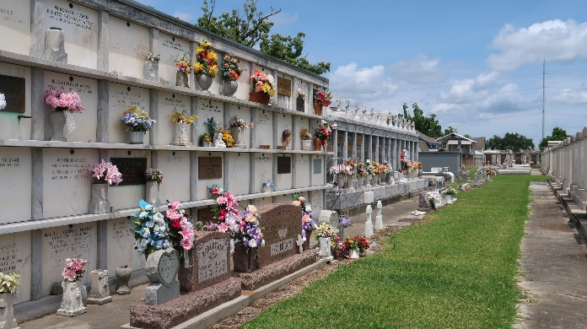

Therese Hymel Cambre passed away on September 5, 2016. She was 92 a native of Destrehan, LA and a resident of LaPlace, LA.

Beloved wife of the late Foster L. Cambre. Mother of Janet Ann Faucheux (the late David, Sr.), Karen Deslatte (Herman), Dale Cambre, Sr.(Dorine) and the late Malcolm Cambre. Daughter of the late Elise Schexnayder and Olidy Hymel. Sister of Nola St. Pe, Betty Faucheux and the late Elma Zeringue, Virginia Eliser, Edward Hymel, Beatrice Hymel, Harold Hymel, Grace Pierson and Norman Hymel. Grandmother of David, Melissa, Jeffrey, Jeanine, Christina, Yvette, Melanie, Melinda, Dale, Jr., Ryan and the late Mary Elizabeth. Great-grandmother of Adam, Lauren, Cole, Shelby, Alex, Julie, Isabella, Ciara, Sarah, Emma, Zachery, Gabriel and Foster. Great-great-grandmother of Ava. Also survived by many nieces and nephews.
Family and friends are invited to attend the Funeral Mass at St. Joan of Arc Catholic Church, 529 W. 5th St., LaPlace on Thursday, September 8, 2016 at 12:00 p.m. Visitation at the church from 10:00 a.m. until 12:00 p.m. Interment in St. Peter’s Cemetery. Arrangements by Millet-Guidry Funeral Home.

Millet-Guidry Funeral Home, LaPlace, Louisiana

