Una (Montz) Cambre

October 10, 1933 – July 27, 1979

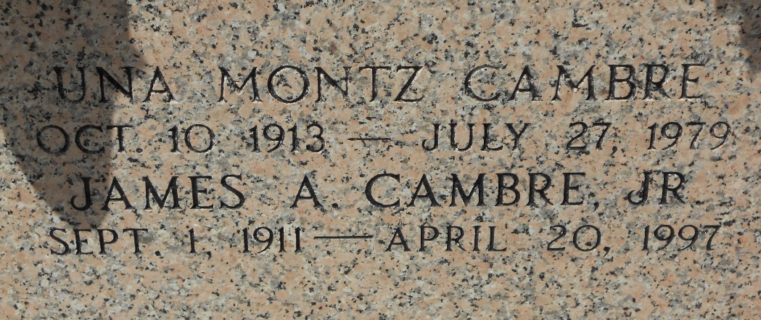

Photo by Team T-Lo

Age 65 years, a native and resident of Reserve, Louisiana. Wife of James Cambre Jr of Reserve, mother of Kendall M Cambre of Destrehan, Louisiana, and James A Cambre III of Reserve. Sister of Andrew O Montz and Joseph C Montz and the late Nolan Montz and Audrey Frantz.

Services were Saturday 28 Jul 1979 at St Peter Church, Reserve, with interment in St Peter Cemetery.

The Times-Picayune, New Orleans, Louisiana

July 28, 1979