Virginie (Cambre) Cambre
July 8, 1887 – August 11, 1971

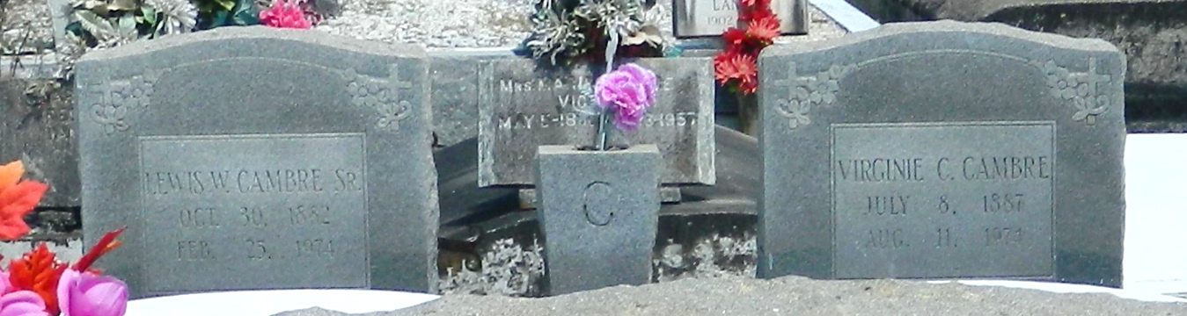

Age 87 years, a native and resident of Reserve, Louisiana, wife of the late Lewis W Cambre Sr.

Mother of Mrs. L. J. (Louise) Roussell Sr, Caliste Cambre, Mrs. Wilbur (Rita) Morvant, Mrs. Raymond (Ruth) Brignac Sr, and Mrs. Oliver (Aline) Duhe Jr, all of New Orleans, Ellis Cambre of Gretna, Louisiana, Bert Cambre of Mobile, Alabama, Lewis Cambre Jr of Garyville, Louisiana, Mrs. Jack (Josie) Snowdy of Reserve, and Russell Cambre, U.S. Army.

Sister of Sidney Cambre of Reserve, Mrs. Zepherin Perilloux of Goodhope, Louisiana, and Roland Cambre of Lafayette, Louisiana, and the late Dewey Cambre.

Services were Wednesday 14 Aug 1974 at St Peter Church, Reserve, with interment in St Peter Cemetery.

The Times-Picayune, New Orleans, Louisiana
August 13, 1974

