Donald James Cancienne

September 26, 1927 – June 20, 2010

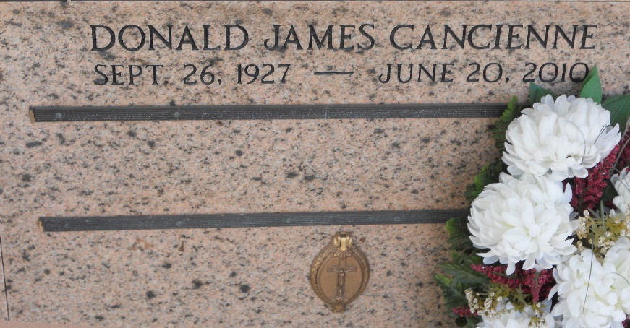

Photo by Team T-Lo

 Donald (Don) Cancienne passed away on Sunday, June 20, 2010.

Beloved husband of Rita Jacob Cancienne. Father of Timothy and wife Mary, Barry and wife Michelle, Brian and wife Suzanne, Darren Cancienne and Greta Kenney and husband Martin. Grandfather of Timothy Jr., Brooke, Brian Jr., Heather, Trevor, Evan and Jared. Son of the late George and Ida Adolph Cancienne. Brother of George, Jr. and Robert Cancienne, Rosalie Terrio, Amy Troxler, Odette Wilson and the late Adelle Cancienne. Age 82 years. A native and resident of Reserve.

Relatives and friends are invited to attend services. Visitation at Millet-Guidry Funeral Home, 2806 W. Airline Hwy, Laplace, on Tuesday, June 22, 2010 from 5:00 PM until 9:00 PM and on Wednesday from 8:00 AM until 9:45 AM. Followed by a Mass at 10:00 AM at St. Peter Catholic Church, Reserve. Burial in St. Peter Cemetery.

The Times-Picayune, New Orleans, Louisiana

Jun. 22, 2010