George Henry Cancienne Sr.

January 4, 1884 – May 11, 1945

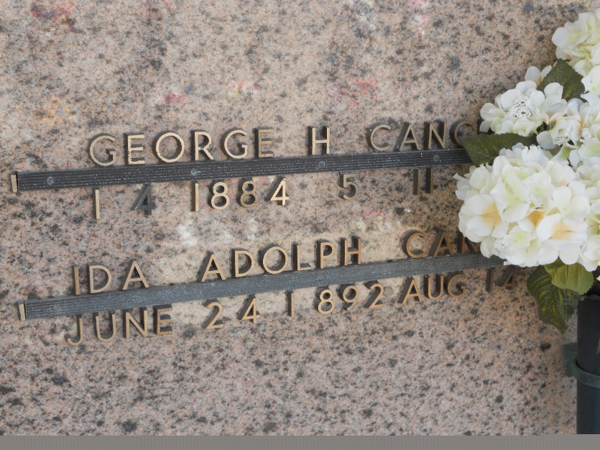

Photo by Team T-Lo

Age 61 years, 4 months, 7 days, a native of Assumption Parish, Louisiana, and a resident of Reserve, Louisiana. Died at the home of his brother John, in White Castle, Louisiana.

Husband of Ida Adolph. Father of Mrs. Larry Terrio and Mrs. K. I. Troxler of Reserve, Sergeant George Cancienne Jr, U.S.A., Donald, Odette and Robert Cancienne, all of Reserve.

Services were Saturday 12 May 1945 at St Anne Church, Napoleonville, Louisiana, with interment in the Catholic cemetery.

The Times-Picayune, New Orleans, Louisiana

May 12, 1945