Ida Rosalie (Adolph) Cancienne

June 24, 1892 – August 14, 1980

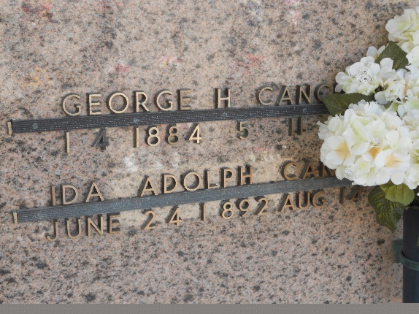

Photo by Team T-Lo

Ida Adolph Cancienne died on Thursday 14 Aug 1980 at 4:15 p.m. at age 88 years.

She was the wife of the late George H Cancienne Sr and the mother of Rosalie C Terrio, Amy C Troxler, George H Cancienne Jr, Donald J Cancienne, all of Reserve, Louisiana, Odette C Wilson of Country Club Hills, Illinois, and Robert A Cancienne of Baton Rouge, also the late Adele Cancienne. Also survived by 32 grandchildren and 13 great grandchildren.

She was the daughter of the late Victor Emile Adolph and Lillia Templet Adolph and the sister of the late Emilie A Bourgeois, Eloise A Gilbert, Rita A Cancienne, Lillie A Bourgeois, Annie A Breaux, Antoinette Adolph, George, Charles and Henry Adolph. She was a native of Napoleonville, Louisiana, and a resident of Reserve for the past 55 years.

Funeral services were from Millet Funeral Home, Reserve, on Saturday 16 Aug 1980 with religious services as St Peter Church, Reserve. Interment in St Peter Cemetery, Reserve.

The Times-Picayune, New Orleans, Louisiana

August 16, 1980