Karen (Harris) Cancienne
April 6, 1962 – July 30, 1997

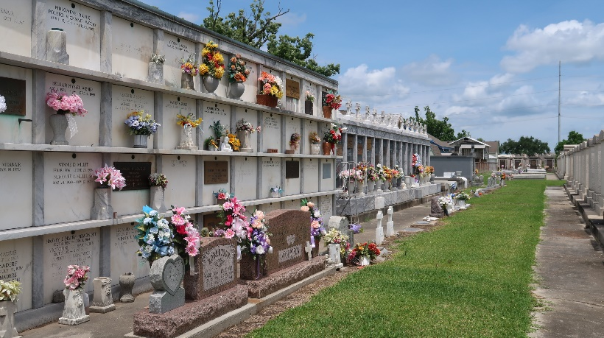
Photo by Team T-Lo

Karen Harris Cancienne, A Homemaker, Died Wednesday Of Cancer At Her Home. She Was 35.

Mrs. Cancienne Was Born In Bogalusa And Lived In Reserve For The Past 15 Years. She Was A Parishioner Of St. Peter Catholic Church.

Survivors Include Her Husband, Wayne Cancienne; A Son, Wade Cancienne; A Daughter, Cara Cancienne; Two Brothers, Charles And Paul Harris Jr., Both Of Bogalusa; Her Parents, Paul And Barbara Morton Harris Of Bogalusa; And Her Grandmother, Beulah Harris Miley Of Bogalusa.

A Mass Will Be Said Friday At 10 A.M. At St. Peter Catholic Church On West Seventh Street In Reserve. Burial Will Be In The Church Cemetery. Millet Guidry Funeral Home Is In Charge Of Arrangements.

The Times-Picayune, New Orleans, Louisiana
July 31, 1997

