Shirley Marie (Oubre) Cancienne
January 27, 1934 – July 14, 2015

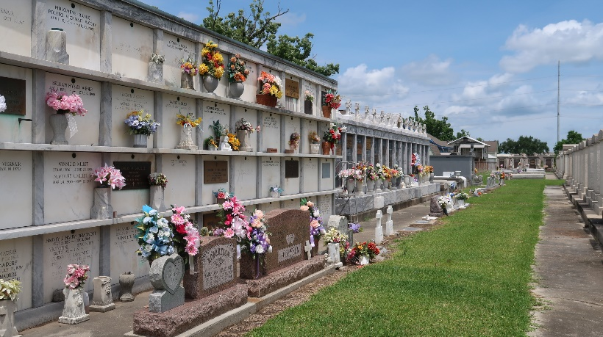
Photo by Team T-Lo

Shirley Marie Cancienne passed away on Tuesday, July 14, 2015.

Beloved wife of the late George H. Cancienne, Sr. Mother of Craig Cancienne (Beth), Wayne Cancienne (Grace), Jason Cancienne (Gina), Donna Mabile (Terry), George Cancienne, Jr., Alan Cancienne (Gina), and Randy Cancienne (Michelle). Grandmother of Craig, Brent, Aaron, Jason, Chris, Jonathan, Wade, Coryn, and Cade Cancienne, Michael, David, and Steven Mabile, Laura Cangiamilla and Cara Keating. She also had 14 great-grandchildren.

Daughter of the late Honore B. and Stella Poche Oubre. Sister of Rose Louque and the late Otis Oubre, Virginia Lassere and Alice Oubre. Age 81, born in Lutcher, LA and a long time resident of Reserve, LA.

Relatives and friends are invited to attend the Funeral Mass at St. Peter Catholic Church, 1550 Hwy 44, Reserve, LA on Friday, July 17, 2015 at 11:00 a.m. Visitation will begin in church at 9:00 a.m. Interment will follow in St. Peter Cemetery. To view or sign the online guest book please visit
www.milletguidry.com

The Times-Picayune, New Orleans, Louisiana
July 15-17, 2015

