Rita M. Cascio

October 24, 1922 – April 6, 2001

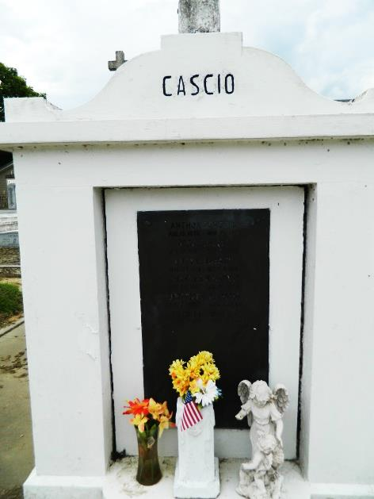 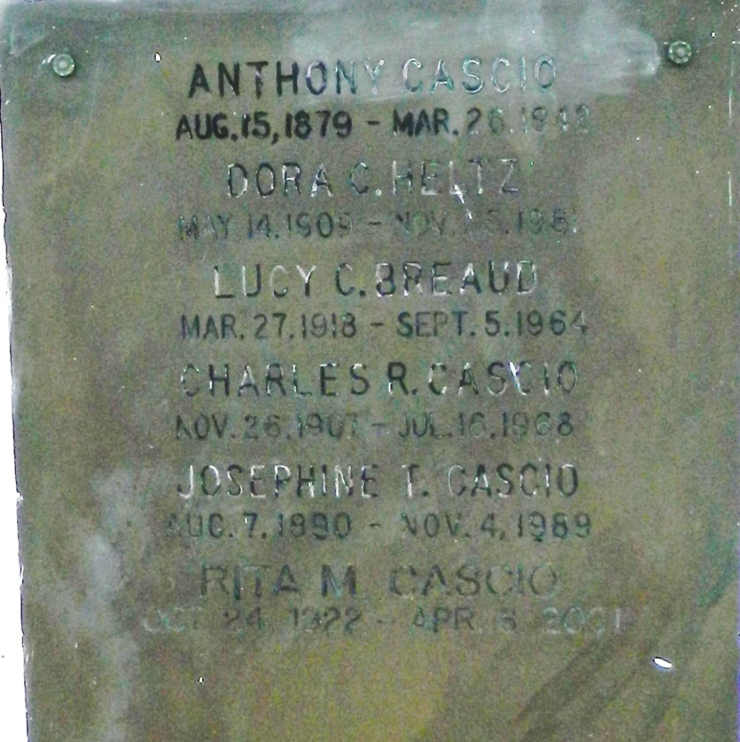

CASCIO LAPLACE - Rita M. Cascio, 78, a native and resident of Reserve, died April 6. She was the daughter of the late Tony and Josephine Cascio and sister of Sam Cascio and the late Frances Burr, Dora Heltz, Lucy Breaud and Charles Cascio. Services were April 9 at St. Peter Catholic Church, Reserve, with interment at the church cemetery.

**L'Observateur (La Place, LA) - Wednesday, April 11, 2001**

**Contributed by Jane Edson**