Eva Mae (Kilburn) Casey

May 11, 1926 – May 4, 2005

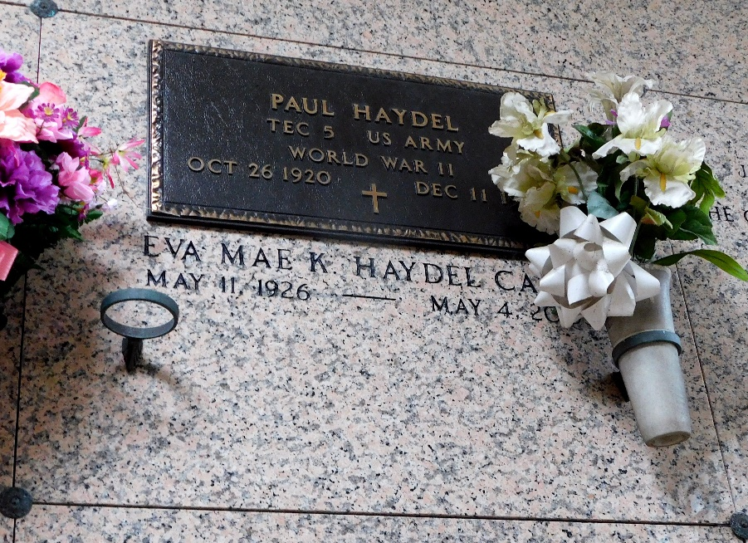

Photo by Mary Agnes Hammett

Eva Mae Kilburn Haydel Casey On Wednesday, May 4, 2005 At 10:30 am.

Beloved Wife By 1st Marriage Of The Late Paul Haydel And By Second Marriage Of The Late Ralph Casey. Mother And Mother-In- Law Of Pauline And Garland Roussel, Fay And Grant Shields, Joy And Glenn Guidry, Debra And Francis Riger, Juliet (Jet) And Larry Templet, Wendy And Danny Kliebert And The Late Julie H. Roussel. Grandmother Of Angela Fasbender, Brant And Grant Shields, Amy Lundy, Andy Roussel, Jeffrey, Joey And Jennifer Guidry, Chris, Clae And Coye Templet, Lori Zeringue, Hallie Roussel, Janie Bowler, Kenny And Lee Kliebert. Also Survived By 15 Great Grandchildren.

Daughter Of The Late Sidney, Sr., And Eva Garcia Kilburn. Sister Of Julie K. Deroche, Farrell, Sr. And Leroy Kilburn And The Late Samuel, Sidney Jr., And Stanley (Peck) Kilburn. Age 78, A Native Of Garyville And A Resident Of Gonzales For The Past 9 Years.

Relatives And Friends Of The Family Are Invited To Attend Services. Visitation At Millet Guidry Funeral Home, 2806 W. Airline Hwy., Laplace On Saturday, May 7, 2005 From 9 Am - 11:30 Am. Followed By Religious Services At St. Hubert Catholic Church, Garyville, La At 12 Noon. Burial In St. Peters Cemetery, Reserve.

The Times-Picayune, New Orleans, Louisiana

May 6, 2005