Joey Floyd Cashio

November 21, 1972 – June 14, 2013

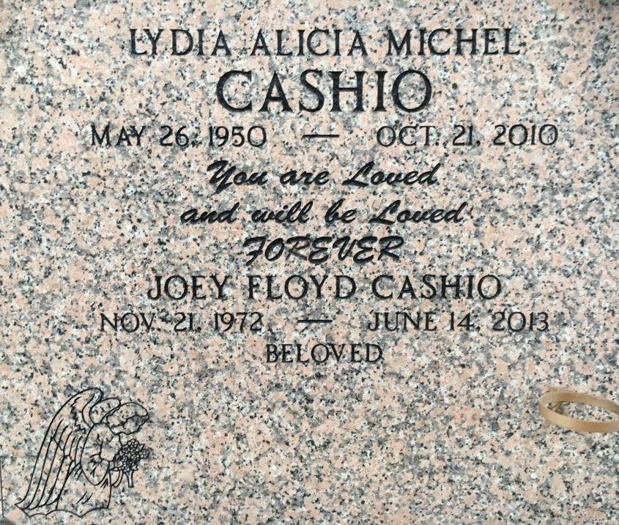

Photo by Team T Lo

"I reached to the sky for the hand of God and was embraced".

Joey Floyd Cashio, age 40, and a resident of St. Amant, LA died June 14, 2013.   
  
Beloved father of Joshua and Abigail.   
Grandfather of Kyleigh Cashio.   
Former spouse of Wanda Madere.   
Son of Gary and the late Lydia Michel Cashio.   
Grandson of Floyd and Hazel Michel and the late Joseph and Anna Cashio.   
Also survived by his sister, Gaylyn Cashio and his brother and sister-in-law, Samy and Lacy Cashio.   
Loved by a host of aunts, uncles, cousins, nieces and nephews.   
  
Visitation at St. Anne Catholic Church, Sorrento on Tuesday, June 25, 2013 at 8:30am, followed by a memorial mass at 10:30. In lieu of flowers, please make donations to a charity of your choice in Joey's name. Church Funeral Services, St. Amant, in charge of arrangements.   
  
TheAdvocate.com, Baton Rouge, LA; from June 20 to June 25, 2013