Lillie Mae (Millet) Cashio

December 26, 1916 – October 20, 2012

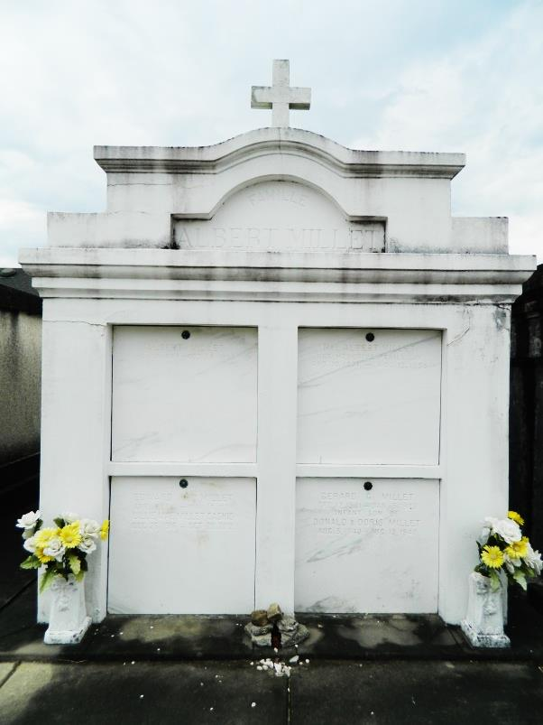 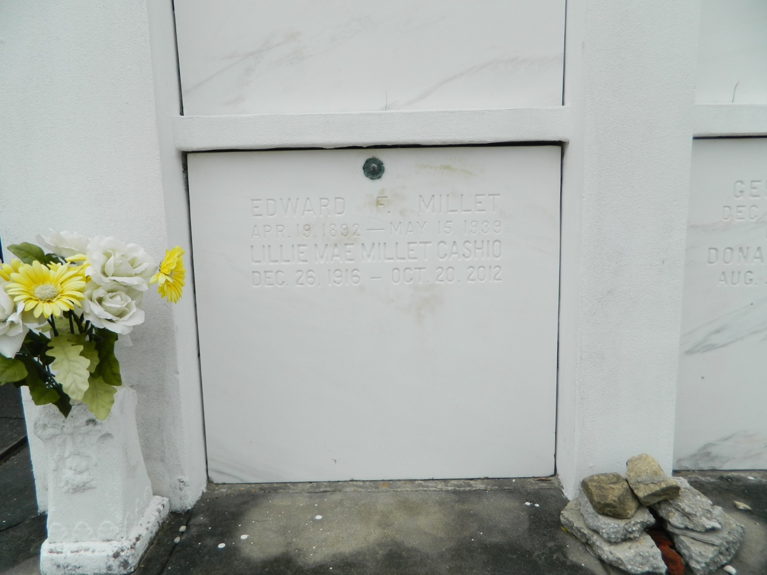

Lillie Mae Millet Cashio passed away on Saturday October 20, 2012.

Beloved wife of the late Andrew (BeBe) Cashio Sr. Mother of Andrew (Burt) (Joyce), David (Cheryl), Curtis (Nancy) Cashio, Kathleen (FeFe) (Philip), Bruce (Jeanette), Richard (Carolyn), Harold (Chesley) Cashio, Lillie Mae (MaeMae) Millet (Kirt) Michael (Petey) Theresa Cashio and the late June Madere (Burton). Mother -in-law of Carolyn McClure. Also Survived by 24 grandchildren and numerous great-grandchildren. Daughter of the late Albert and Honorine Perilloux Millet. Age 95. A native of Lyons, LA and a resident of Reserve, La.   
 Relatives and friends are invited to attend services. Visitation at St. Joan of Arc Catholic Church, 529 W. 5th St., LaPlace, LA on Monday October 22, 2012 from 9:30 am to 11:00 am, followed by Mass at 11:00 am. Burial in St. Peter Cemetery, Reserve, LA.

Special thanks to Carolyn and Richard for their loving care given to MawMaw. Arrangements by Millet-Guidry Funeral Home, LaPlace, LA.

Times-Picayune, The (New Orleans, LA)

Sunday, October 21, 2012