Lydia Alicia (Michel) Cashio

May 26, 1950 – October 21, 2010

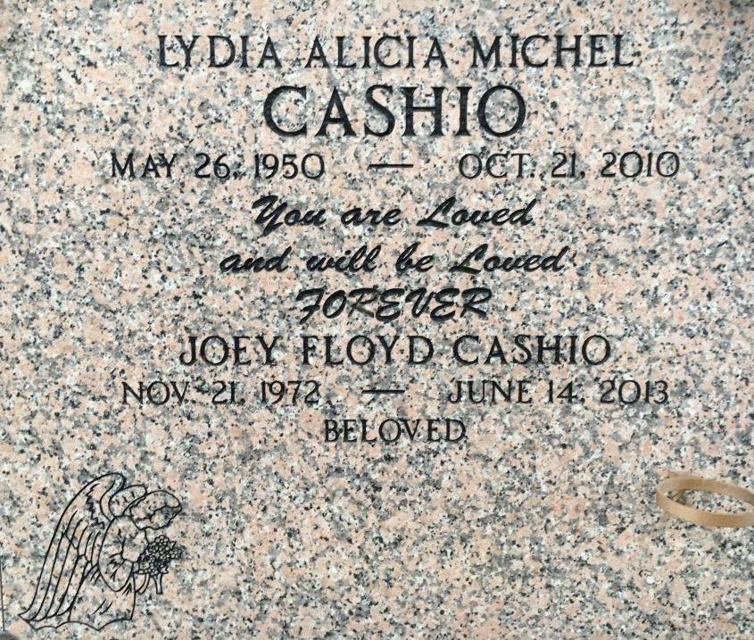

Photo by Team T Lo

Lydia Michel Cashio, beloved wife and best friend of Gary J. Cashio for 42 years, passed away peacefully at her home on Thursday, October 21, 2010. A native of Garyville, La. and a resident of St. Amant, La. She leaves to cherish her memory her daughter Gaylyn Cashio, her son Joey Cashio and her son Samy Cashio (Lacy), grandchildren Taylor, Sarah, Julia, Caroline, Joshua, AbiGail and James, great-grandchild Kaleigh. Daughter of Floyd and Hazel Michel. Sister of Cheryl Keller (Gerald), Floyd Bosco Michel (Loma Linda), Merry Gay Vicknair (Carl), Jeffery Michel (Lisa) and Allison Michel. She will be greatly missed by her aunts, uncles, cousins, nieces, nephews and numerous friends. She was truly an angel on earth. "Faith is the substance of things hoped for and the evidence of things not seen". Relatives and friends of the family are invited to attend the Funeral Mass at St. Hubert Catholic Church, Garyville, La. on Tuesday, October 26, 2010 at 12:00 pm. Interment in St. Peter Cemetery, Reserve, La. Friends may visit at the church from 9:00 am until time of service. Arrangements by Millet-Guidry Funeral Home, LaPlace, La.

Times Picayune, New Orleans, LA; 10/24/2010