Nicholas Joseph Cashio Jr.
February 2, 1944 – February 27, 2023

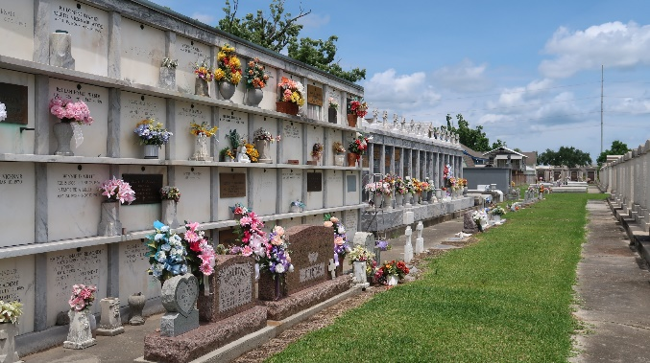

Nick was the beloved husband of Cathy Weaver Cashio for almost 50 years since June 1973. He was a loving father to Steven Craig (Jennifer), Lori Elizabeth, and John Ryan, and a devoted grandfather to Cooper and Chloe. He is also survived by sisters Corliss Klibert and Mary (Mike) Punch, his niece and goddaughter, Marcy Punch, and numerous nieces and nephews.
He was preceded in death by his parents Nicholas Cashio Sr., born in White Castle LA; Mamie (Mica) DeMarco, born in Napoleonville, LA; and his brother Darryl, born in Reserve LA.
Nick has been a lifelong resident of south Louisiana. Born in Reserve and resided in Baton Rouge the last 36 years. After attending elementary school at St. Peter's Catholic School in Reserve, he graduated from St. Joseph Seminary in St. Benedict, Louisiana in 1962. After leaving the seminary for high school, he attended Southeastern and USL, earning a Bachelor degree in Political Science. Nick obtained his Masters degree in Social Work during his career working for the State Department of Children and Family Services for over 39 years. He worked in the River Parishes, LaFourche Parish, and East Baton Rouge.
His friends and family knew him as a quiet man who was devoted to the Catholic faith, most recently a parishioner of St. Thomas More Catholic Church and former member of their choir. He fed hearts around him with his smile and peaceful personality, fed minds with his extensive repertoire of trivia, and fed stomachs with his delicious home cooked meals. Nick enjoyed countless holidays and celebrations with his close and extended family, and reunions with his fellow classmates from St. Joseph Seminary. He will be missed dearly by all.
Family and friends are invited to attend the Visitation and Funeral Mass at St. Peter Catholic Church, 1550 Hwy 44 Reserve, LA 70084, on Saturday, March 11, 2023. Visitation from 8:30 till 11:30 a.m. followed by a Funeral Mass at 11:00 a.m.
In lieu of flowers, the family would like all to consider having Masses said in memory of Nick.

Millet-Guidry Funeral Home, LaPlace, Louisiana
February 28, 2023

