Effie (Thibodeaux) Cassagne
February 28, 1907 – April 7, 2003

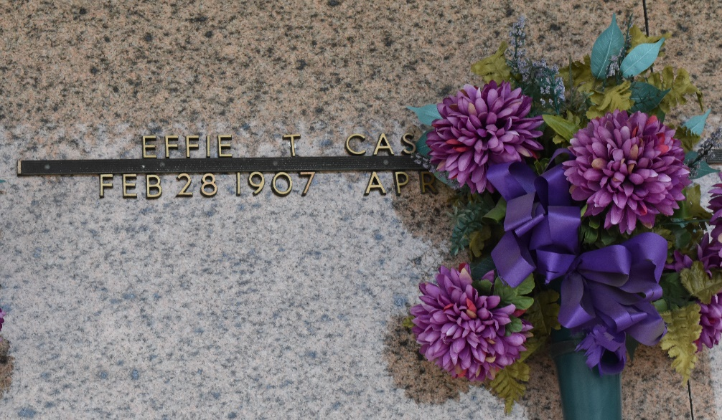

Effie T. Cassagne On Monday, April 7, 2003 At 10:28 A.M.
Beloved Wife Of The Late Leelen P. Cassagne. Mother Of Shirley Terrio, Leatrice 'Cheesie' Keller, Leda Mae 'Mitsy' Madere And The Late L.J. Cassagne. Daughter Of The Late Nicholas And Mathielda Vice Thibodeaux. Sister Of Aurelia Colon, The Late George And Valley Thibodeaux And Mae Clement. Grandmother Of Dr. Leelen Terrio, Barry Terrio, Belinda Millet And Georgia Conway. Great-Grandmother Of Melissa Simoneaux, Steven Terrio, Megan And Monica Millet, Lacey Burns And The Late Nicholas Millet. Great-Great-Grandmother Of Austin And Alexandra Simoneaux. Age 96 Years. A Native Of Laplace, La And Resident Of Reserve, La For The Past 79 Years.
Relatives And Friends Of The Family Are Invited To Attend Services. Visitation At St. Peter Catholic Church, Reserve, La On Wednesday, April 9, 2003 From 10:00 A.M. Until 12:00 Noon. Followed By Religious Services At St. Peter Catholic Church At 12:00 Noon. Burial In St. Peter Cemetery. Arrangements By Millet-Guidry Funeral Home, Laplace, La.
Times Picayune, New Orleans, Louisiana
April 8, 2003

