Frances Myrtle (Cason) Cassagne
July 22, 1917 – July 22, 2002

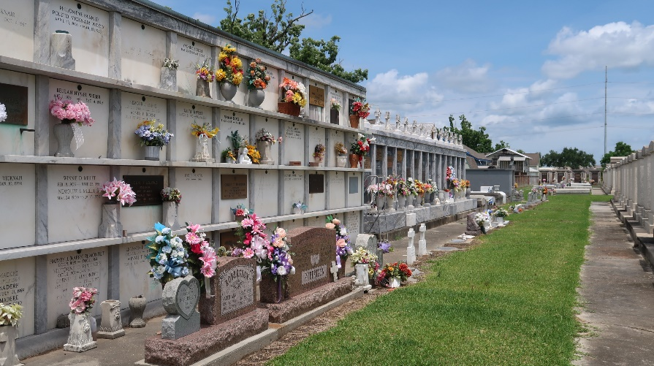

Frances Cason Cassagne On Monday, July 22, 2002 At 4 am.

Beloved Wife Of The Late Rodney A. Cassagne. Daughter Of The Late William And Bertha Cason. Sister Of William R. Cason Jr. Of Arabi, La. And The Late Winston'sporty'cason. Also Survived By Nieces And Nephews. Age 85. A Native Of Garyville, La. And A Resident Of St. Francesville, La. For The Past 50 Years.

Relatives And Friends Of The Family Are Invited To Attend Services. Visitation At Millet-Guidry Funeral Home, 2806 West Airline Hwy, Laplace, La. On Wednesday, July 24, 2002 From 9 Am To 10:30Am. Followed By Religious Services In The Funeral Home Chapel At 10:30 Am. Burial In St. Peter Cemetery, Reserve, La.
Times-Picayune, New Orleans, Louisiana
July 24, 2002

