Marie Azema (Songy) Cassagne
June 7, 1863 – January 29, 1939

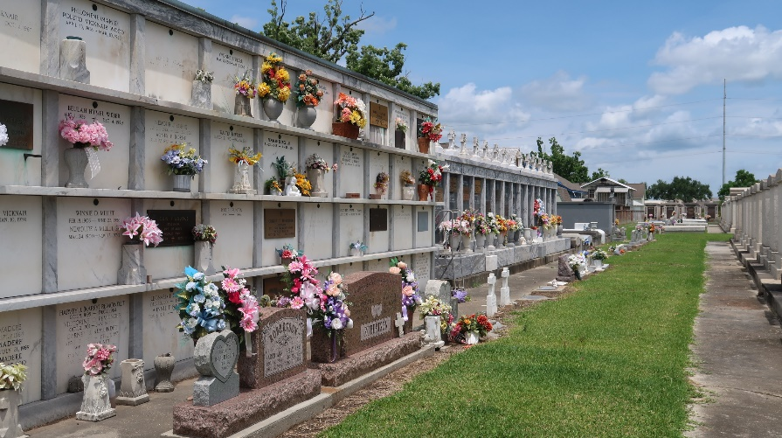

CASSAGNE – At Baptist hospital in New Orleans on Sunday, January 29, 1939, at 1:45 o’clock a.m., Mrs. Charles Cassagne, widow of the late Charles Cassagne, mother of Mrs. Clement Audissred of Reser, La., Mrs. Dennis Madere of Laplace, La., Mrs. Charles J. Grundmann of New Orleans and the late Mrs. Andre Delaneuville of Reserve, La., also survived by 12 grandchildren and 5 great-grandchildren, aged 57 years, a resident of New Orleans for the past year.

Relatives and friends of the family are invited to attend the funeral which will take place Monday morning, January 30, 1939, at 9:30 o’clock from the Jules Millet funeral home, Reserve, La. Religious services at St. Peter’s church, Reserve. Interment in St. Peter’s cemetery, Reserve, La.
Unknown newspaper clipping

