Noelie Marie (Schexnayder) Cassagne

December 25, 1916 – June 11, 2008

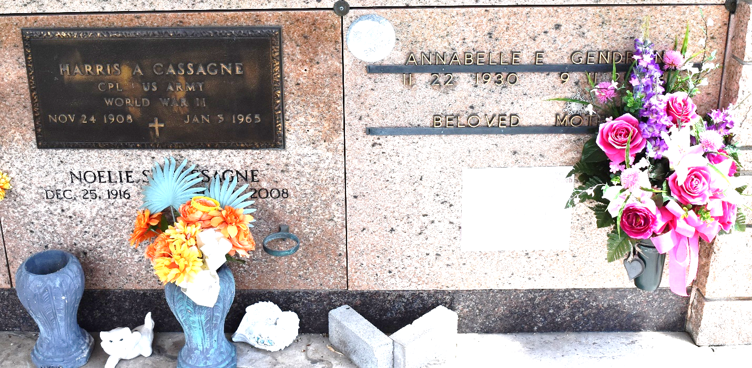

Noelie Schexnayder Cassagne on Wednesday, June 11, 2008 at 8:45AM.

Beloved wife of the late Harris Cassagne, Sr. Mother of Harris, Jr. and wife Paula D. Cassagne, Charles Michael and wife Sandra O. Cassagne, Daryl Cassagne, Mark Cassagne and the late Carolyn Ann Cassagne. Also survived by seven grandchildren and six great-grandchildren. Age 91. A native of Montz, LA and a resident of Reserve, LA.

Relatives and friends are invited to attend services. Visitation at Millet-Guidry L.L.C. Funeral Home, 2806 W. Airline Highway, LaPlace, LA on Thursday, June 12, 2008 from 5:00PM to 7:00PM and on Friday from 10:00AM to 11:30AM. Followed by Religious Services at St. Peter Catholic Church, Reserve at 12:00 noon. Burial in St. Peter Cemetery in Reserve, LA.

The Times-Picayune, New Orleans, Louisiana

June 12, 2008