Paul P. Cassioppi

February 4, 1914 – August 23, 2000

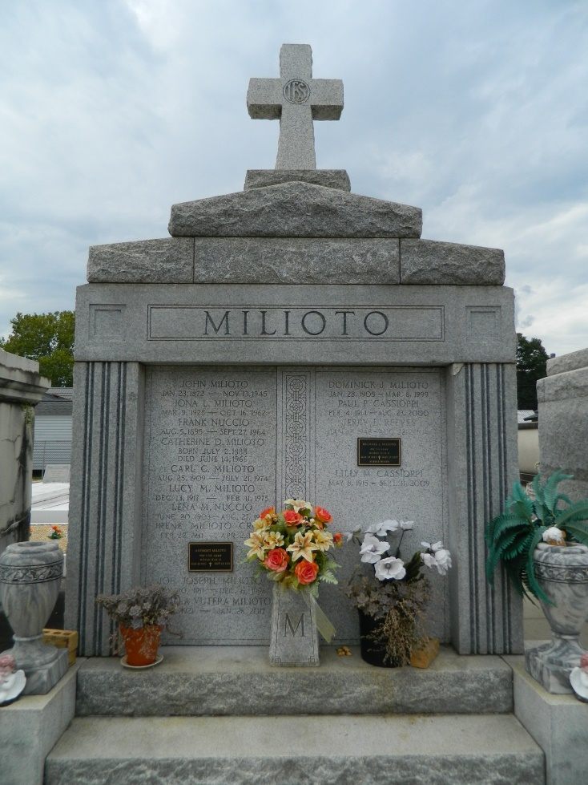 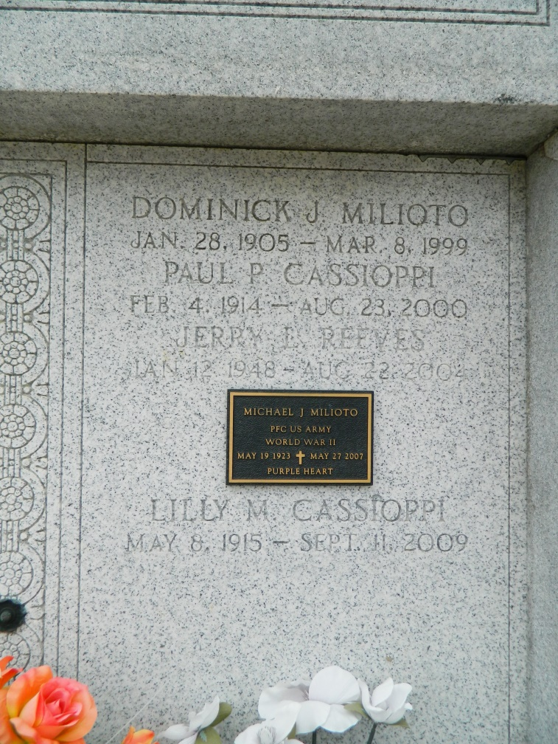

Paul P. Cassioppi, a retired station attendant for Airline Motors, died Wednesday at River Parishes Hospital in LaPlace. He was 86. Mr. Cassioppi was a native of Rockford, Ill., and lived in LaPlace for 56 years. He was employed by Airline Motors for 40 years. He was a parishioner of St. Joan of Arc Catholic Church and a charter member and third-degree Knight of the Knights of Columbus No. 5935. Mr. Cassioppi also was a charter member of the LaPlace Volunteer Fire Department. Survivors include his wife, Lily Milioto Cassioppi; a son, Joey Cassioppi; four grandchildren; and a great-grandchild. A Mass will be said Saturday at 9:30 a.m. at St. Peter Catholic Church in Reserve. Visitation will be today from 5 to 9 p.m. and Saturday from 8 to 9:30 a.m. at Millet Guidry Funeral Home in LaPlace. Burial will be in St. Peter's Cemetery. Millet Guidry Funeral Home is in charge of the arrangements.

Times-Picayune, The (New Orleans, LA) - Friday, August 25, 2000

Contributed by Jane Edson