Sandra Adele (Church) Castelo
October 8, 1945 – September 22, 2009

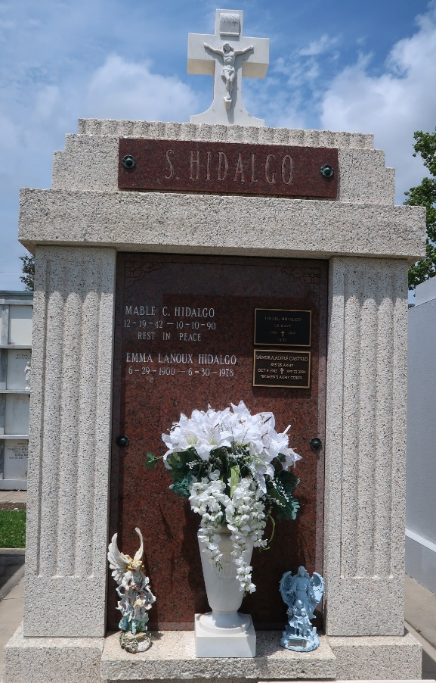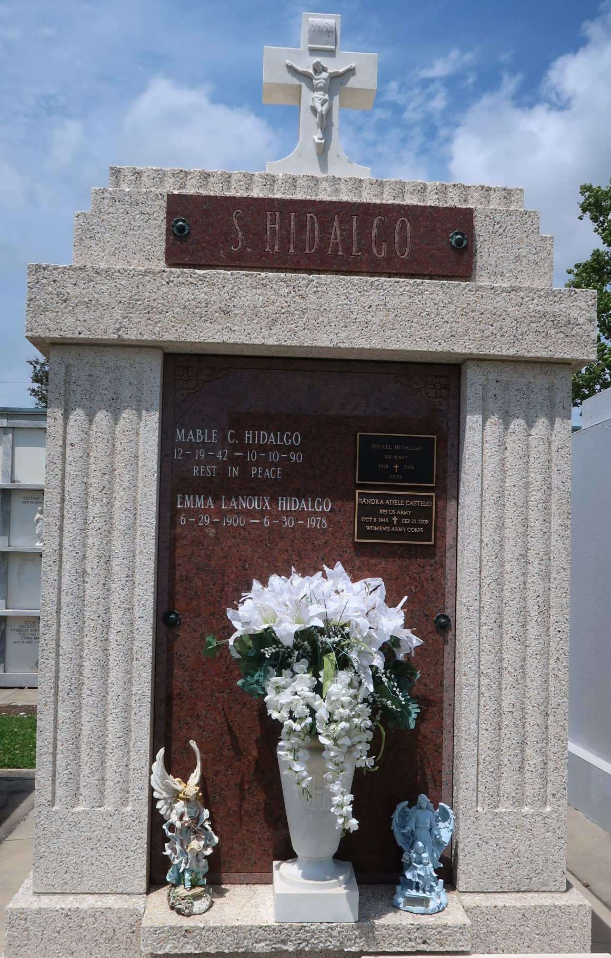

A resident of St. Amant, she died on Tuesday, Sept. 22, 2009, at Gonzales Health Care. She was 63. She proudly served her country during the Vietnam Era in the U.S. Army with 12 years of service.
Visitation at Ascension Funeral Home, 426 W. New River St., Gonzales, on Thursday, Sept. 24, from 5 p.m. to 9 p.m., with recitation of the rosary at 7 p.m. Visitation at St. Mark Catholic Church, Gonzales, on Tuesday, Sept. 29, from 9 a.m. until a memorial Mass at 10 a.m., with the Rev. Rubin Reynolds, celebrant. Interment in St. Peter Catholic Church Cemetery, Reserve.
Survived by her daughter, Juana Castelo; sister, Debbie Becnel and her husband, Michael; and brother, Donald R. Church Jr. and his wife, Norma. Preceded in death by her parents, Donald R. Church Sr. and Doris E. Hildago Church.
In lieu of flowers, memorial donations may be made to Alzheimer's Services of the Capital Area, 3772 North Blvd., Baton Rouge, LA 70806-3822. www.ascensionfuneral.com.

The Advocate, Baton Rouge, Louisiana
Sep. 24 to Sep. 27, 2009

