Alice (Keating) Catoir

September 26, 1879 – October 3, 1959

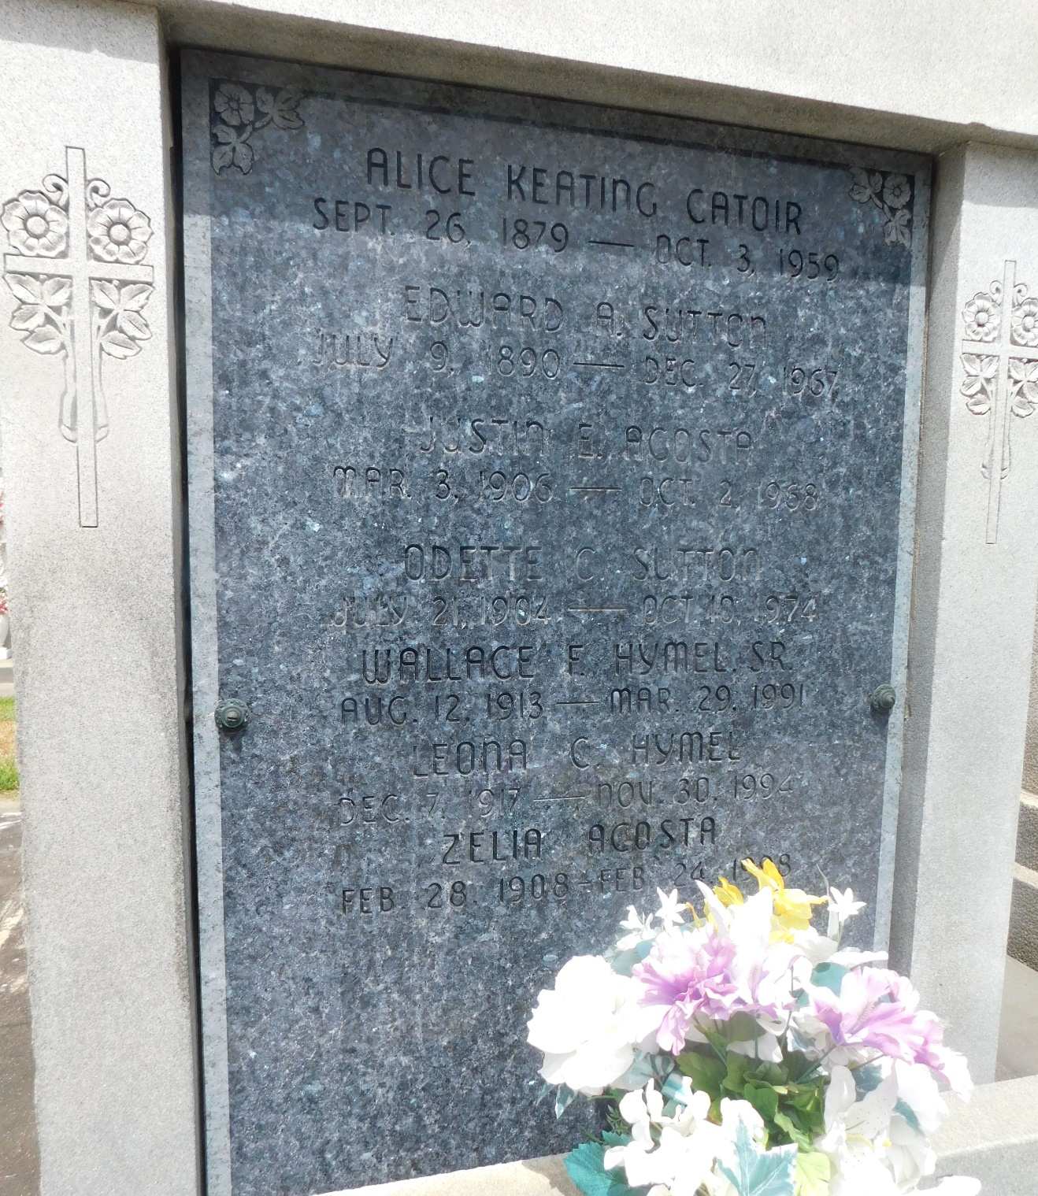

Photo by Mary Agnes Hammet

Alice Keating Catoire died in Reserve, Louisiana, on Saturday 3 Oct 1959 at 6:00 pm at age 80 years.

She was the wife of the late Leonce Catoire and the mother of Leon Catoire of Laplace, Louisiana, Wilson Catoire, Mrs. Odette Sutton, Mrs. Zelia Acosta and Mrs. Wallace Hymel, all of Reserve. She was the sister of John Keating and the late McDuff Keating and Mrs. Prudent Heltz.

Services were Monday 5 Oct 1959 at St Peter Church, Reserve, with interment in St Peter Cemetery, Reserve.

The Times-Picayune, New Orleans, Louisiana

4 Oct 1959