Alvin J. Catoire
May 27, 1932 – October 10, 2003
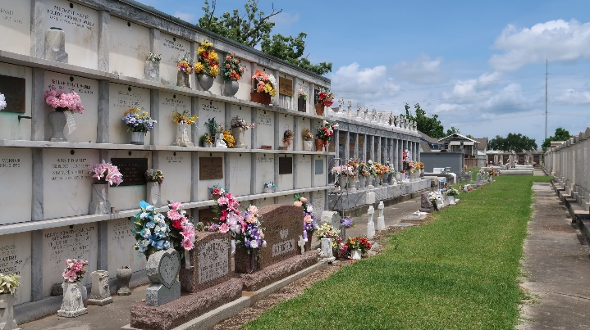

Alvin J. Catoire, On Friday, October 10, 2003 At 10:25 A.M.
Beloved Husband Of Dorothy Holmes Catoire. Father Of Dorothy Clark, Cathy Gaudet And Joyce Chatelain. Son Of The Late Stanley And Odelia Jacob Catoire. Brother Of Eldon (Dunny) And Phil Catoire, Mary Rose Abate And The Late Belle Geiling, Samuel Catoire And Ruth Bordelon, Edwin (Shorty) Catoire. Also Survived By 8 Grandchildren And 13 Great-Grandchildren. Age 71. A Native And Resident Of Reserve, La.
Relatives And Friends Of The Family Are Invited To Attend Services. Visitation At Millet-Guidry Funeral Home, 2806 W. Airline Hwy, Laplace, La. On Sunday, October 12, From 5 Pm To 10 Pm And On Monday From 8 Am To 10 Am, Followed By Religious Services In The Funeral Home Chapel At 10 Am. Burial In St. Peter Cemetery, Reserve, La.
Times Picayune, New Orleans, Louisiana
October 11, 2003

