Charles Lawrence Catoire
August 16, 1925 – February 7, 2024

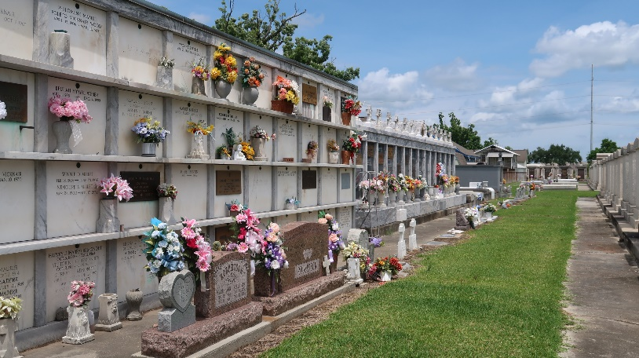

Charles Lawrence Catoire a lifelong resident of LaPlace, passed away on Wednesday, February 7, 2024 at the age of 98.
Beloved husband to Melba Clement Catoire, for 70 years. Loving father of Karen Liautaud (John) and Eric Catoire (Michelle). Grandfather of Brandon Pickering (Kristie), Jenna Liautaud, John Robert Liautaud, III, Erica Bonura (John), Natalie Dale (Jared), and Clint Catoire (Reyna Cardona). Great-grandfather of Evan Pickering, Ethan Pickering, Mackenzie Bonura, and Stella Dale. Son of the late Charles Catoire and Marie Brack. Brother of Beverly Terrebonne (the late Robert), and the late Florence Forsythe (the late Henry), Rose Forsythe (the late Herbert), and Leroy Catoire (the late Eunice). Also survived by nieces, nephews, and cousins.
Charles proudly served in U.S. Navy during World War II. Charles loved spending time in his garden, he was a true jack of all trades and was always looking for his next adventure. He was a handyman, especially if the fix required duct tape.
The family would like to express their gratitude to Egan Ochsner Home Health, the staff at St. Charles Parish Hospital, and to all the sitters that have cared for their family.
Relatives and friends are invited to attend the Funeral Mass at St. Joan of Arc Catholic Church, 529 W. 5th Street, LaPlace on Thursday, February 15, 2024 at 12:00 p.m. Visitation from 10:00 a.m. until 12:00 p.m. Interment in St. Peter Cemetery, Reserve, LA.

Millet-Guidry Funeral Home, LaPlace, Louisiana

