Elma (Bourgeois) Catoire

September 9, 1902 – September 10, 2000

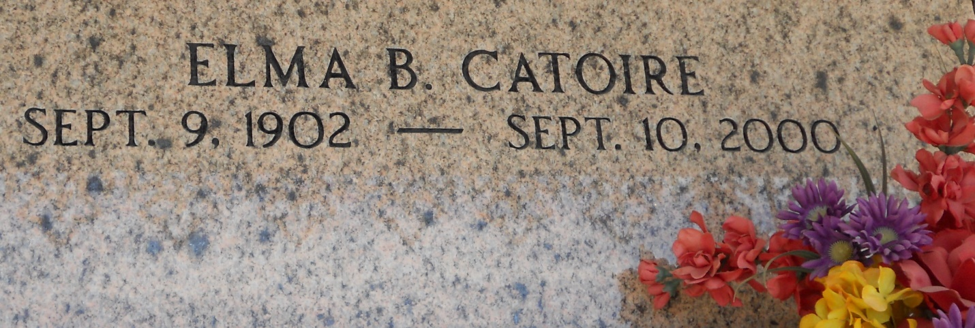

Photo by Team T-Lo

Elma Bourgeois Catoire, 98, a native of Paulina and resident of Reserve for 76 years, died Sept. 10. She was the wife of the late Guy J.Catoire and mother of Elaine Miano, Miriam Bannon, Dorrel Catoire and the late Ray and Clyde Catoire Sr.  
  
She was also the daughter of the late Prudent and Florestine Brignac Bourgeois and sister of the late Elvire Loupe, Elvina Kliebert, Elmire Gaudet and Gaston, Leston, Victor and Clovis Bourgeois.  
  
She is also survived by 13 grandchildren and 22 great-grandchildren.  
  
Services at St. Peter Catholic Church, Reserve, with interment at the church cemetery.  
  
L’Observateur, LaPlace, Louisiana

September 13, 2000