Gladys Bertille Juliette (Madere) Catoire
December 28, 1912 – October 22, 2005
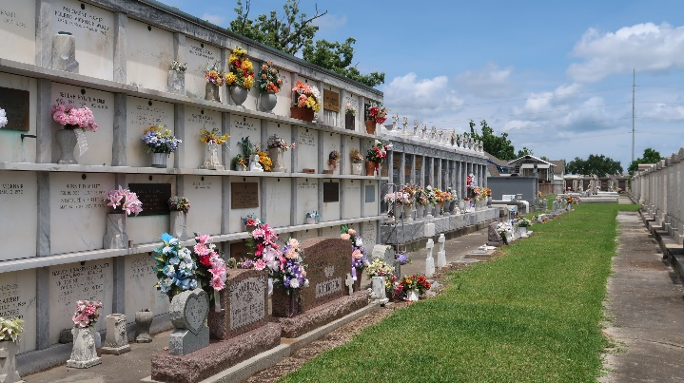

Gladys Madere Catoire On Saturday, October 22, 2005 At 3:30 A.M.

Beloved Wife Of The Late Leo J. Catoire, Sr. Mother Of Leo, Jr., (L. J.), Wilfred (Skinny) And George Catoire. Also The Late Priscilla C. Richard, Bruce Catoire And Diana C. Trosclair. Daughter Of The Late Wilfred And Louise D. Madere. Also Survived By 25 Grandchildren And Numerous Great Grandchildren And Great-Great-Grandchildren. Age 92. A Native And Resident Of Reserve.

Relatives And Friends Of The Family Are Invited To Attend Services. Visitation At Millet-Guidry Funeral Home, 2806 W. Airline Hwy, Laplace On Tuesday, October 25, 2005 From 5pm To 8pm And On Wednesday From 8am To 9:30 Am. Followed By Religious Services At St. Peter Catholic Church, Reserve At 10:00am. Burial In St. Peter Cemetery, Reserve.
Times Picayune, New Orleans, Louisiana
October 25, 2005

