Guy Joseph Catoire
March 12, 1900 – June 15, 1977

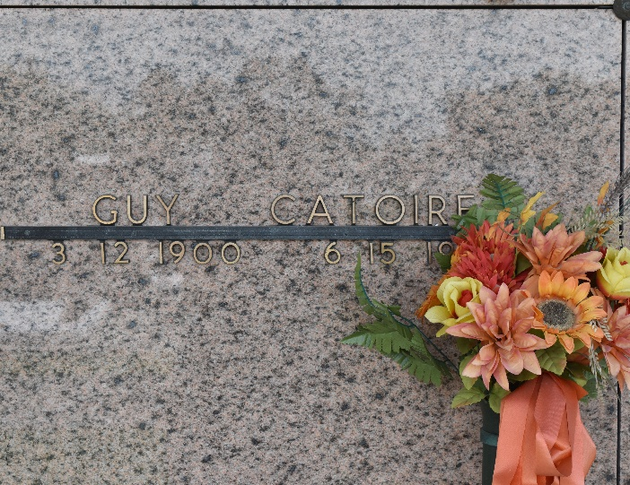

Guy Joseph Catoire, on Wednesday, June 15, 1977 at 2 p.m., beloved husband of Mrs. Elma Bourgeois Catoire; Father of Clyde G. Catoire, Mrs. Miriam Bannon, Mrs. Elaine Miano, Dorrel P. Catoire and the late Paul R. Catoire; also survived by 11 grandchildren and 1 great-grandchild; brother of Mrs. Antoinette Triche, Mrs. Eugenie Klibert, Mrs. Rosie Jacob and the late Mrs. Paul Duhe, Mrs. Ida Vicknair and Mrs. Mederic Duhe, Mrs. Lea Delaneuville, Willie, Walter, Stanley and Leo Catoire; age 77 years, a native and a resident of Reserve, La.
Relatives and friends of the family are invited to attend the funeral services from Millet Funeral Home, Reserve, La., on Friday, June 17, 1977 at 10 a.m. followed by religious services at St. Peter Catholic Church. Interment in church cemetery. Friends may call from 5 until 10 p.m. on Thursday, June 16, 1977 and from 8 a.m. Friday, June 17, 1977 until time of services.

The Times-Picayune, New Orleans, Louisiana
Thursday, June 16, 1977
Section 1, page 24

