James Eldon Catoire
December 6, 1933 – January 26, 2019

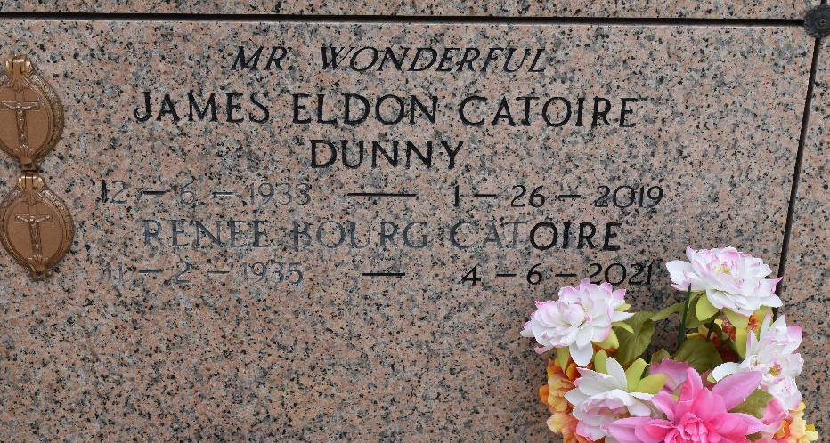

James "Dunny" Eldon Catoire Sr. passed away on January 26, 2019. He was born on December 6, 1933. He was a native and resident of Reserve, LA.
He was survived by his wife, Renee Bourg Catoire: children, Eldon Catoire (Kim), Chuck Catoire (Charlotte), Kim Catoire Boynton (Ben) and Stanley Catoire (Tina). He has 8 grandchildren: Amy, Brandy, Christopher, Tina, Candace, Shirley, Stanley Jr. and Ben. He is also survived by 17 great grandchildren and 1 great great grandchild.
He was the son of the late Stanley Joseph Catoire and Odelia Jacob Catoire. Brother of Phil Catoire and the late Samuel "Sam" Catoire, Joseph Catoire (died at birth), Edwin "Shorty" Catoire, Alvin "Al" Catoire, Belle Catoire Geiling, Mary Rose Catoire Abate, and Ruth Catoire Bordelon. He was also loved by numerous nieces and nephews.
Family and friends are invited to attend the visitation on Wednesday, January 30, 2019 from 9:00 am until 11:00 am at St. Peter Catholic Church (located at 1550 Hwy 44 Reserve, LA) followed by a prayer service and then burial in St. Peter Cemetery. Arrangements by Millet–Guidry Funeral Home, 2806 West Airline Hwy LaPlace, LA 70068.

The New Orleans Advocate, Louisiana
January 27 - 30, 2019

