Marie Eva (Jacob) Catoire
September 11, 1870 – March 10, 1945

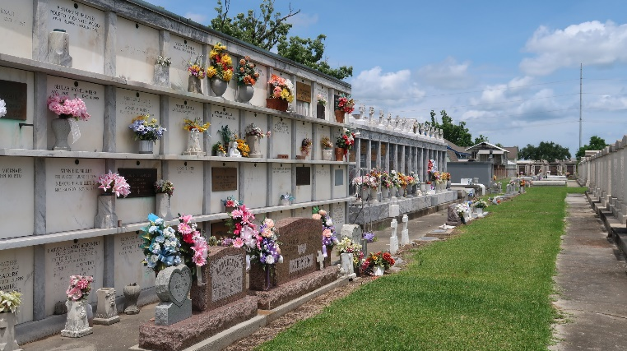

Marie Eva Jacob, wife of the late George Catoire, died Saturday, 10 Mar 1945, at age 74 years, 5 months and 29 days.

She was the mother of Mrs. Adolph Delauneville, Mrs. Mederic Duhe, Mrs. Charles Triche, Mrs. Elmore Klibert, Mrs. Whitney Jacob and Willie, Walter, Stanley and Guy Catoire.

Services were Monday, 12 Mar 1945, at St Peter Church, Reserve, Louisiana, with interment in St Peter Cemetery.

The Times-Picayune, New Orleans, Louisiana
March 11, 1945
Page 8

