Melba L. (Clement) Catoire

February 4, 1931 - January 12, 2020

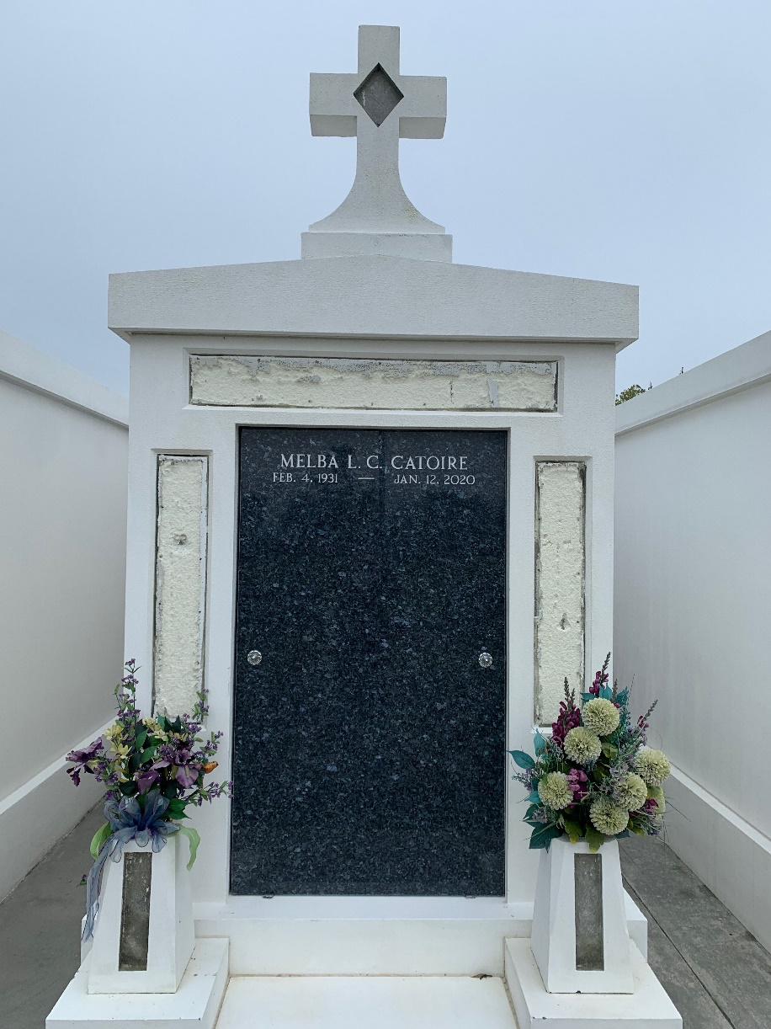

Photo by Team T-Lo

Melba Clement Catoire passed away on Sunday, January 12, 2020. She was 88 and was a native and life-long resident of LaPlace, LA.  
 Beloved wife of Charles Lawrence Catoire. Loving mother of Karen Liautaud (John) and Eric Catoire (Michelle). Grandmother of Brandon Pickering (Kristie), Jenna Liautaud, John Robert Liautaud, III, Erica Catoire (John Bonura), Natalie Dale (Jared) and Clint Catoire. Great-grandmother of Evan and Ethan Pickering. Daughter of the late Aline Melancon Clement and William Clement. Sister of Juliette Alford, Gerald Clement, Carmen Weber and the late Dan Clement, Lillie Mae Starks, Nina Scalco, Roy Clement, Helen Satterlee, William Clement, Jr. and Elizabeth Cehlar. Also survived by many nieces and nephews.  
 Relatives and friends are invited to attend the Funeral Mass at St. Joan of Arc Catholic Church, 529 W. 5th Street, LaPlace on Thursday, January 16, 2020 at 11:30 a.m. Visitation from 9:30 a.m. until 11:30 a.m. Interment in St. Peter Cemetery, Reserve, LA. Arrangements by Millet-Guidry Funeral Home.

Millet-Guidry Funeral Home, LaPlace, Louisiana

January 15, 2020