Odile (Clement) Catoire
June 23, 1848 – June 21, 1909

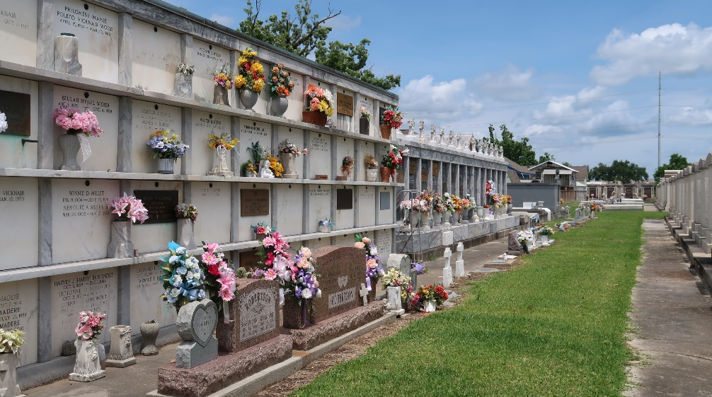
Photo by Team T-Lo

On Monday evening, at 6 o'clock, Mrs. Eughemon (sic-Euphemon) Catoir died at her residence on the left bank, at the age of 66 years. She was sick only a few hours when the sad end came.
She was preceded to the grave about six weeks ago by her husband. She leaves eight children to mourn her death.
Le Meschacébé, Reserve, Louisiana
26 Jun 1909, p 1

Note: She is listed as Mme. Euphemon Catoire in the index to St Peter Church Funeral Register III, p 94.

