Renee (Bourg) Catoire
November 2, 1935 – April 6, 2021

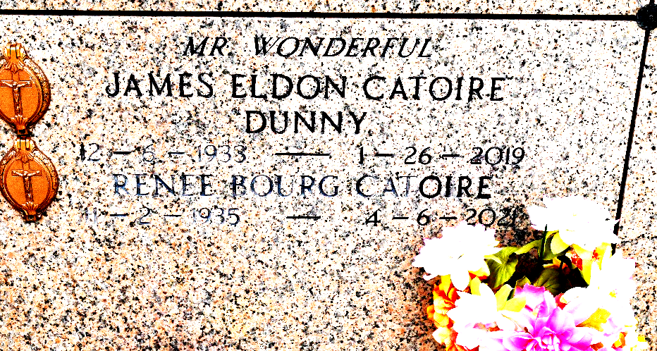

Renee Bourg Catoire passed away on Tuesday, April 6, 2021, at age 85.

She was born on November 2, 1935 to the late John W. Bourg and Denise Montz Bourg. She was a native and resident of Reserve. She is survived by her children, James Eldon Catoire, Jr. (Kim), Chuck Catoire, Kim Catoire Boynton (Ben), and Stanley Catoire (Tina); sister, Jo Ann Bourg Beadle; brother, Neil Bourg (Madeline); 8 grandchildren: Amy, Brandy, Christopher, Tina, Ben, Candace, Shirley and Stanley Jr.; 18 great grandchildren; 2 great-great grandchildren; and former daughter-in-law, Charlotte Catoire.

Preceded in death by her husband, James "Dunny" Eldon Catoire, Sr.; sisters, Marie "Sis" Bourg Duhon and Laura Mae Bourg Trosclair; brothers, Luke "LP" Bourg, Leo Bourg and John "Buddy" Bourg. She will be sadly missed by all who knew and loved her.

Due to Covid the family has requested a small intimate graveside service on Saturday, April 10, 2021 at 10:00 a.m. at St. Peter's Catholic Church in Reserve, LA.
Millet-Guidry Funeral Home, LaPlace, Louisiana
April 8, 2021

